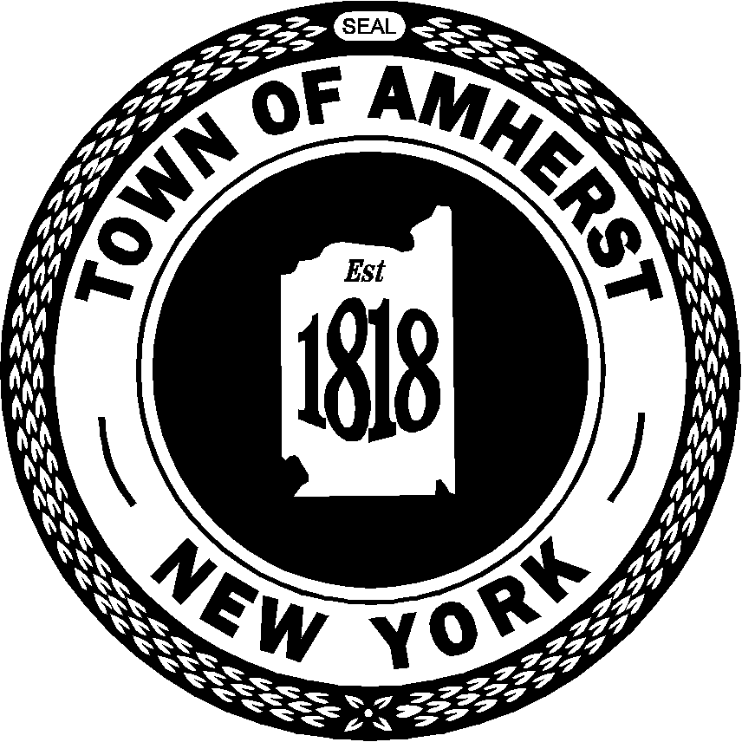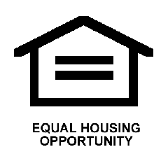

**DRAFT**

### Amherst HOME Consortium

**Consolidated Plan Annual Performance**

**and**

**Evaluation Report**

**for the period**

### April 1, 2014 to March 31, 2015



### Amherst Community Development Block Grant

and

**HOME Investment Partnership Grant**

for

**(Amherst, Cheektowaga and Tonawanda)**

*Prepared by:*

*Town of Amherst Planning Department*

*Contact Person: Susan DiVita*

*5583 Main Street*

*Williamsville, NY 14221*

*Telephone: (716) 631-7082*

**DRAFT COPY MADE AVAILABLE FOR CITIZEN REVIEW ON JUNE 15, 2015**

**All Town Libraries-Village Clerk-Town Clerk-Supervisor-Councilmembers-Town Website**

**Written comments to be received by the**

**Town of Amherst Planning Department**

**5583 Main Street**

**Williamsville, NY 14221**

**No later than 5:00 PM, Friday, June 26, 2015**

**Written comments received: y__** **n __**

**Contents:**

**SECTION I**

**2014 Consolidated Plan Annual Performance and Evaluation Report (CAPER)**

**Narrative for Fiscal Year 2014 Performance**

**HOME Program Annual Performance Report (HUD40107)**

**HOME Match and MBE/WBE Report pg. 10-14**

**SECTION II - REPORTS**

**CDBG Financial Summary Performance Report (PR26)**

**Grantee Summary of Accomplishments CDBG - HOME FY2014 Report (PR23)**

**Summary of Consolidated Plan 2014 Projects (PR06)**

**Summary of Activities Report (PR03)**

**CDBG Performance Measures Report (PR83)**

**Section 1- Public Facilities - Services – Infrastructure and Economic Development**

**Section 2- Rental Housing Rehabilitation/Construction**

**Section 3- Owner Occupied Housing Rehabilitation - Acquisition/Rehabilitation -**

**Construction**

*Please call this department at (716) 631-7082 or provide written requests to:*

* ***Town of Amherst Community Development Program***

5583 Main Street, Williamsville, NY 14221

## Amherst – Cheektowaga – Tonawanda HOME Consortium

**2014 Consolidated Plan Annual Performance and Evaluation Report (CAPER)**

## CR-05 - Goals and Outcomes

**Progress the jurisdiction has made in carrying out its strategic plan and its action plan. 91.520(a)**

This could be an overview that includes major initiatives and highlights that were proposed and executed throughout the program year.

This Fiscal Year’s report concludes the overview of the Town’s Five Year Consolidated Plan from 2010-2014 and the Annual Action Plan for 2014 for CDBG and HOME funding.

Single family owner-occupied home rehabilitation continues to be the main focus of the Community Development Block Grant and HOME Investment Partnerships Grant programs in the Town.  Many of the older homes in the first ring suburbs require extensive general maintenance and are occupied by many of the lower income and senior households in the Town with little disposable income to afford the upkeep.   The Town’s Housing Rehabilitation Program offers eligible homeowners 0% interest loans to do the necessary repairs required to provide a safe and secure home.  These loans do not have to be repaid until sale or transfer of the property.  During the 2014 program year, April 1, 2014 through March 31, 2015, the Town of Amherst provided $558,359 in housing rehabilitation loans to eligible owners of thirty nine (39) single family homes. This sum includes $168,311 in CDBG funds, $155,150 in HOME funds, and $109,664 in NYS Affordable Housing Corp. funds expended during this period.  Lead paint hazards were removed from sixteen (16) homes in Amherst.

In addition to housing rehabilitation loans, HOME funds are used to purchase foreclosed, vacant and deteriorated residential property in Amherst for rehabilitation and resale to an income eligible first-time homebuyer.  This activity is accomplished in conjunction with the Town’s designated Owner Developer, New Opportunities Community Housing Development Corp. through an agreement with New Opportunities, a property on Garland Drive in Eggertsville was purchased in April 2014. This property was previously owned by an absentee landlord and used as a rental property for local college students for a period of years.  After substantial renovation, this house was sold to an eligible first time homebuyer and returned to owner occupancy in this residential neighborhood.

HOME funds were also used to assist seven (7) individual first-time homebuyers in purchasing homes in Amherst during the 2014 program year.

**Comparison of the proposed versus actual outcomes for each outcome measure submitted with the consolidated plan and explain, if applicable, why progress was not made toward meeting goals and objectives. 91.520(g)**

Categories, priority levels, funding sources and amounts, outcomes/objectives, goal outcome indicators, units of measure, targets, actual outcomes/outputs, and percentage completed for each of the grantee’s program year goals.

|  |  |  |  |  |  |  |  |  |  |  |
| --- | --- | --- | --- | --- | --- | --- | --- | --- | --- | --- |
| **Goal** | **Category** | **Source / Amount** | **Indicator** | **Unit of Measure** | **Expected – Strategic Plan** | **Actual – Strategic Plan** | **Percent Complete** | **Expected – Program Year** | **Actual – Program Year** | **Percent Complete** |
| Affirmatively Further Fair Housing | Affordable Housing Public Housing Non-Homeless Special Needs | CDBG: $4500 | Public service activities other than Low/Moderate Income Housing Benefit | Persons Assisted | 0 | 0 |  | 0 | 0 |  |
| Affirmatively Further Fair Housing | Affordable Housing Public Housing Non-Homeless Special Needs | CDBG: $4500 | Public service activities for Low/Moderate Income Housing Benefit | Households Assisted | 25 | 92 | 368.00% | 70 | 92 | 131.43% |
| Historic Preservation/ /Elimination of Slum and Bl | preservation of historic sites and eliminate blight | CDBG: $34615 | Facade treatment/business building rehabilitation | Business | 1 | 1 | 100.00% | 1 | 1 | 100.00% |
| Improve Housing Stock |  | CDBG: $94447 / HOME: $92361 | Homeowner Housing Rehabilitated | Household Housing Unit | 25 | 24 | 96.00% | 30 | 39 | 130.00% |
| Promote Affordable Homeownership | Affordable Housing | HOME: $20000 | Public service activities other than Low/Moderate Income Housing Benefit | Persons Assisted | 0 | 0 |  | 70 | 99 | 141.43% |
| Promote Affordable Homeownership | Affordable Housing | HOME: $20000 | Direct Financial Assistance to Homebuyers | Households Assisted | 4 | 7 | 175.00% | 4 | 4 | 100.00% |
| Provide Assistance to Homeless Population | Affordable Housing Homeless | CDBG: $0 | Tenant-based rental assistance / Rapid Rehousing | Households Assisted | 1 | 0 | 0.00% |  |  |  |
| Provide Assistance to Homeless Population | Affordable Housing Homeless | CDBG: $0 | Overnight/Emergency Shelter/Transitional Housing Beds added | Beds | 4 | 6 | 150.00% | 4 | 6 | 150.00% |
| Provide Assistance to Homeless Population | Affordable Housing Homeless | CDBG: $0 | Homelessness Prevention | Persons Assisted | 4 | 0 | 0.00% |  |  |  |
| Rental Housing Owner-occupied Rehabilitation | Affordable Housing | CDBG: $0 | Public service activities for Low/Moderate Income Housing Benefit | Households Assisted | 1 | 0 | 0.00% |  |  |  |
| Rental Housing Owner-occupied Rehabilitation | Affordable Housing | CDBG: $0 | Rental units rehabilitated | Household Housing Unit | 1 | 0 | 0.00% |  |  |  |
| Special Needs Population | Affordable Housing Non-Homeless Special Needs | CDBG: $8000 | Public service activities other than Low/Moderate Income Housing Benefit | Persons Assisted | 5 | 43 | 860.00% | 8000 | 8000 | 100.00% |
| Special Needs Population | Affordable Housing Non-Homeless Special Needs | CDBG: $8000 | Homeowner Housing Rehabilitated | Household Housing Unit | 5 | 1 | 20.00% |  |  |  |
| Weatherization Assistance | Affordable Housing | CDBG: $2500 | Public service activities for Low/Moderate Income Housing Benefit | Households Assisted | 15 | 15 | 100.00% |  |  |  |
| Weatherization Assistance | Affordable Housing | CDBG: $2500 | Rental units rehabilitated | Household Housing Unit | 0 | 0 |  | 1 | 1 | 100.00% |
| Weatherization Assistance | Affordable Housing | CDBG: $2500 | Homeowner Housing Rehabilitated | Household Housing Unit | 0 | 0 |  | 24 | 12 | 50.00% |

Table 1 - Accomplishments – Program Year & Strategic Plan to Date

**Assess how the jurisdiction’s use of funds, particularly CDBG, addresses the priorities and specific objectives identified in the plan, giving special attention to the highest priority activities identified.**

Single family owner-occupied home rehabilitation continues to be the main focus of the Community Development Block Grant and HOME Investment Partnerships Grant programs in the Town.  Many of the older homes in the first ring suburbs require extensive general maintenance and are occupied by many of the lower income and senior households in the Town with little disposable income to afford the upkeep.   The Town’s Housing Rehabilitation Program offers eligible homeowners 0% interest loans to do the necessary repairs required to provide a safe and secure home.  These loans do not have to be repaid until sale or transfer of the property.  During the 2014 program year, April 1, 2014 through March 31, 2015, the Town of Amherst provided $558,359 in housing rehabilitation loans to eligible owners of thirty nine (39) single family homes. This sum includes $168,311 in CDBG funds, $155,150 in HOME funds, and $109,664 in NYS Affordable Housing Corp. funds expended during this period.  Lead paint hazards were removed from sixteen (16) homes in Amherst.

**Additional CDBG Non-Housing Services**

CDBG funds continue to support: Family Service Counseling for at risk families through Catholic Charities; Boys and Girls Club after school services; Housing Counseling and Financial Education services; air Housing activities; and Foreclosure Prevention Counseling. The Amherst Senior Center through the purchase of a new wheelchair accessible van for our senior residents with disabilities; CDBG Community Policing program through the Towns Police Department providing additional bicycle and foot patrols in target neighborhoods; Dedicated Code Enforcement program throughout the target areas of the Town benefiting residents of Eggertsville and Creek Woods neighborhoods. These Public Service and Fair Housing activities have a proven, positive impact on the quality of life and well-being of the residents of the neighborhoods in the Towns target areas.

**CR-10 - Racial and Ethnic composition of families assisted**

**Describe the families assisted (including the racial and ethnic status of families assisted). 91.520(a)**

|  |  |  |
| --- | --- | --- |
|  | **CDBG** | **HOME** |

|  |  |  |  |
| --- | --- | --- | --- |
|  |  |  |  |
| White | 74 | 63 |
| Black or African American | 58 | 12 |
| Asian | 1 | 8 |
| American Indian or American Native | 0 | 0 |
| Native Hawaiian or Other Pacific Islander | 0 | 0 |

|  |  |  |  |
| --- | --- | --- | --- |
|  |  |  |  |
| **Total** | **133** | **83** |

|  |  |  |  |
| --- | --- | --- | --- |
|  |  |  |  |
| Hispanic | 2 | 12 |
| Not Hispanic | 131 | 71 |

Table 2 – Table of assistance to racial and ethnic populations by source of funds

**Narrative**

The American Communities Survey data for 2013 illustrates the demographics of the Town showing the population in the Town of Amherst as predominately White or Caucasian, (83%), approximately 6% African American and 7.6% Asian. The Town's programs offering these families assistance and funded through CDBG are mostly public service youth programs and counseling and fair housing programs.  While a large number of the families assisted are White and African American and English speaking, many of the families have English as a second language.  The top four languages spoken beside English are Mandarin Chinese, Russian, Korean and Spanish, in that order.  Many of the children have parents studying at the University and others, Russian families mainly, are immigrant families sponsored by local congregations.

## CR-15 - Resources and Investments 91.520(a)

**Identify the resources made available**

|  |  |  |  |
| --- | --- | --- | --- |
| **Source of Funds** | **Source** | **Resources Made Available** | **Amount Expended During Program Year** |
| CDBG |  |  | 643,248 |
| HOME |  |  | 1,184,896 |

Table 3 - Resources Made Available

**Narrative**

In 2014 the Town of Amherst received $494,500 Community Development Block Grant funding and $112,841 CDBG program income returned from previous activities. CDBG expenditures for 2014 totaled $643,248.11 entitlement and program income for all Block Grant projects.

HOME funds received in 2014 include $720,089 Federal (Entitlement) funding and $340,319.06 program income.  This funding is shared between the three Towns of the HOME Consortium.  Total expenditures for the HOME program include $769,385.90 EN and $415,509.89 in program income for the three Towns in the Consortium.

**Identify the geographic distribution and location of investments**

|  |  |  |  |
| --- | --- | --- | --- |
| **Target Area** | **Planned Percentage of Allocation** | **Actual Percentage of Allocation** | **Narrative Description** |
| Eggertsville | 60 | 60 |  |
| Town Wide | 30 | 30 | Town Wide |
| Windermere-Meadow Lea | 10 | 10 |  |

Table 4 – Identify the geographic distribution and location of investments

**Narrative**

The majority of the expenditures for the Town of Amherst's Community Development Program are concentrated in the Eggertsville neighborhoods.  Housing rehabilitation is the largest expenditure using both CDBG and HOME funds supplemented by the NYS Affordable Housing Grant.  This area, as a first ring suburb, is one of the older, less affluent portions of the Town and as such seems to be in greater need of assistance to maintaining the housing.

The neighborhoods in Eggertsville have a larger low - moderate income population and many of the public service programs are also focused on the families here.  The Eggertsville Community Center is central to this part of Town and is home to the Boys and Girls Club after school programs assisted with CDBG funds.  Community Policing and Code Enforcement programs are also a high priority in these neighborhoods to enhance the quality of life for the residents.

**Leveraging**

**Explain how federal funds leveraged additional resources (private, state and local funds), including a description of how matching requirements were satisfied, as well as how any publicly owned land or property located within the jurisdiction that were used to address the needs identified in the plan.**

The Town has once again been awarded a $300,000 New York State Affordable Housing Grant that offers a 60/40 match for the Town's CDBG and HOME housing rehabilitation programs.  This funding is available to low mod residents eligible under HUD's income guidelines for assistance and is offered as a forgiven grant to supplement the Town's 0% deferred loan for housing repairs.

Community Development does not utilize any publicly owned land for its programs.

| **Fiscal Year Summary – HOME Match** | |
| --- | --- |
| 1. Excess match from prior Federal fiscal year | 4,976,244 |
| 2. Match contributed during current Federal fiscal year | 111,816 |
| 3. Total match available for current Federal fiscal year (Line 1 plus Line 2) | 5,088,060 |
| 4. Match liability for current Federal fiscal year | 124,484 |
| 5. Excess match carried over to next Federal fiscal year (Line 3 minus Line 4) | 4,963,576 |

Table 5 – Fiscal Year Summary - HOME Match Report

| **Match Contribution for the Federal Fiscal Year** | | | | | | | | |
| --- | --- | --- | --- | --- | --- | --- | --- | --- |
| **Project No. or Other ID** | **Date of Contribution** | **Cash**  **(non-Federal sources)** | **Foregone Taxes, Fees, Charges** | **Appraised Land/Real Property** | **Required Infrastructure** | **Site Preparation, Construction Materials, Donated labor** | **Bond Financing** | **Total Match** |
| 1030 Brighton Road | 08/01/2014 | 125 | 0 | 0 | 0 | 0 | 0 | 125 |
| 105 Roswell Drive | 08/07/2014 | 17,071 | 0 | 0 | 0 | 0 | 0 | 17,071 |
| 112 Garland Drive | 09/17/2014 | 501 | 0 | 0 | 0 | 0 | 0 | 501 |
| 1520 Eggert Road | 05/20/2014 | 551 | 0 | 0 | 0 | 0 | 0 | 551 |
| 159 Gould Street | 09/03/2014 | 14,371 | 0 | 0 | 0 | 0 | 0 | 14,371 |
| 2365 Kensington Avenue | 10/23/2013 | 13,711 | 0 | 0 | 0 | 0 | 0 | 13,711 |
| 275 Springville Avenue | 03/03/2014 | 6,534 | 0 | 0 | 0 | 0 | 0 | 6,534 |
| 352 N Ivyhurst Road | 04/03/2014 | 11,573 | 0 | 0 | 0 | 0 | 0 | 11,573 |
| 361 Bryant Street | 03/28/2014 | 13,575 | 0 | 0 | 0 | 0 | 0 | 13,575 |
| 436 Capen Boulevard | 08/14/2014 | 7,557 | 0 | 0 | 0 | 0 | 0 | 7,557 |
| 459 Campus Drive | 12/18/2013 | 10,123 | 0 | 0 | 0 | 0 | 0 | 10,123 |
| 62 Wendover Drive | 07/03/2014 | 12,960 | 0 | 0 | 0 | 0 | 0 | 12,960 |
| 73 Mapleview Drive | 08/04/2014 | 2,828 | 0 | 0 | 0 | 0 | 0 | 2,828 |
| 75 Meadow Lea Drive | 08/06/2014 | 336 | 0 | 0 | 0 | 0 | 0 | 336 |

Table 6 – Match Contribution for the Federal Fiscal Year

**HOME MBE/WBE report**

| **Program Income** – Enter the program amounts for the reporting period | | | | |
| --- | --- | --- | --- | --- |
| **Balance on hand at begin-ning of reporting period**  **$** | **Amount received during reporting period**  **$** | **Total amount expended during reporting period**  **$** | **Amount expended for TBRA**  **$** | **Balance on hand at end of reporting period**  **$** |
| 162,065 | 340,895 | 418,468 | 0 | 84,493 |

Table 7 – Program Income

|  |
| --- |
| **Minority Business Enterprises and Women Business Enterprises –** Indicate the number and dollar value of contracts for HOME projects completed during the reporting period |

|  |  |  |  |  |  |  |
| --- | --- | --- | --- | --- | --- | --- |
|  | **Total** | **Minority Business Enterprises** | | | | **White Non-Hispanic** |
| **Alaskan Native or American Indian** | **Asian or Pacific Islander** | **Black Non-Hispanic** | **Hispanic** |

|  |  |  |  |  |  |  |
| --- | --- | --- | --- | --- | --- | --- |
| **Contracts** | | | | | | |
|  |  |  |  |  |  |  |
| Dollar Amount | 420,938 | 0 | 0 | 2,278 | 0 | 418,660 |
| Number | 42 | 0 | 0 | 1 | 0 | 41 |

|  |  |  |  |  |  |  |
| --- | --- | --- | --- | --- | --- | --- |
| **Sub-Contracts** | | | | | | |
|  |  |  |  |  |  |  |
| Number | 0 | 0 | 0 | 0 | 0 | 0 |
| Dollar Amount | 0 | 0 | 0 | 0 | 0 | 0 |

|  |  |  |  |
| --- | --- | --- | --- |
|  | **Total** | **Women Business Enterprises** | **Male** |

|  |  |  |  |
| --- | --- | --- | --- |
| **Contracts** | | | |
|  |  |  |  |
| Dollar Amount | 418,660 | 0 | 418,660 |
| Number | 42 | 0 | 42 |

|  |  |  |  |
| --- | --- | --- | --- |
| **Sub-Contracts** | | | |
|  |  |  |  |
| Number | 0 | 0 | 0 |
| Dollar Amount | 0 | 0 | 0 |

Table 8 – Minority Business and Women Business Enterprises

|  |
| --- |
| **Minority Owners of Rental Property** – Indicate the number of HOME assisted rental property owners and the total amount of HOME funds in these rental properties assisted |

|  |  |  |  |  |  |  |
| --- | --- | --- | --- | --- | --- | --- |
|  | **Total** | **Minority Property Owners** | | | | **White Non-Hispanic** |
| **Alaskan Native or American Indian** | **Asian or Pacific Islander** | **Black Non-Hispanic** | **Hispanic** |
| Number | 0 | 0 | 0 | 0 | 0 | 0 |
| Dollar Amount | 0 | 0 | 0 | 0 | 0 | 0 |

Table 9 – Minority Owners of Rental Property

|  |
| --- |
| **Relocation and Real Property Acquisition –** Indicate the number of persons displaced, the cost of relocation payments, the number of parcels acquired, and the cost of acquisition |

|  |  |  |
| --- | --- | --- |
|  | **Number** | **Cost** |
| Parcels Acquired | 0 | 0 |
| Businesses Displaced | 0 | 0 |
| Nonprofit Organizations Displaced | 0 | 0 |
| Households Temporarily Relocated, not Displaced | 0 | 0 |

|  |  |  |  |  |  |  |
| --- | --- | --- | --- | --- | --- | --- |
| **Households Displaced** | **Total** | **Minority Property Enterprises** | | | | **White Non-Hispanic** |
| **Alaskan Native or American Indian** | **Asian or Pacific Islander** | **Black Non-Hispanic** | **Hispanic** |
| Number | 0 | 0 | 0 | 0 | 0 | 0 |
| Cost | 0 | 0 | 0 | 0 | 0 | 0 |

Table 10 – Relocation and Real Property Acquisition

## CR-20 - Affordable Housing 91.520(b)

**Evaluation of the jurisdiction's progress in providing affordable housing, including the number and types of families served, the number of extremely low-income, low-income, moderate-income, and middle-income persons served.**

|  | One-Year Goal | Actual |
| --- | --- | --- |
| Number of Homeless households to be provided affordable housing units | 1 | 6 |
| Number of Non-Homeless households to be provided affordable housing units | 25 | 12 |
| Number of Special-Needs households to be provided affordable housing units | 2 | 0 |
| **Total** | **28** | **18** |

Table 11 – Number of Households

|  | One-Year Goal | Actual |
| --- | --- | --- |
| Number of households supported through Rental Assistance | 23 | 28 |
| Number of households supported through The Production of New Units | 0 | 0 |
| Number of households supported through Rehab of Existing Units | 25 | 39 |
| Number of households supported through Acquisition of Existing Units | 2 | 2 |
| **Total** | **50** | **69** |

Table 12 – Number of Households Supported

**Discuss the difference between goals and outcomes and problems encountered in meeting these goals.**

The Town has adjusted its CDBG program objectives as described in the opening narrative to focus the diminished CDBG housing rehabilitation funds on owner occupied single family units.  While the need for affordable rental units is still a concern in the Town, and the Town continues to support the development of senior and affordable rental housing, no new *affordable* multi-family or senior development has been proposed.

**Discuss how these outcomes will impact future annual action plans.**

The priorities of the Town have shifted somewhat during this plan period. While the need for affordable rental housing is still an objective, the maintenance of existing single family housing stock , especially in the older lower income neighborhoods, has become more of a priority for the diminished funding.

**Include the number of extremely low-income, low-income, and moderate-income persons served by each activity where information on income by family size is required to determine the eligibility of the activity.**

|  |  |  |
| --- | --- | --- |
| **Number of Persons Served** | **CDBG Actual** | **HOME Actual** |
| Extremely Low-income | 1 | 7 |
| Low-income | 0 | 10 |
| Moderate-income | 2 | 30 |
| **Total** | **3** | **47** |

Table 13 – Number of Persons Served

**Narrative Information**

The number of extremely low-income, low-income, and moderate-income persons served by each activity where information on income by family size is required to determine the eligibility of the activity as listed above includes those assisted with homebuyer assistance, housing rehabilitation, both CDBG, HOME and State funding and one homebuyer for the Acquisition-Rehab home.

## CR-25 - Homeless and Other Special Needs 91.220(d, e); 91.320(d, e); 91.520(c)

**Evaluate the jurisdiction’s progress in meeting its specific objectives for reducing and ending homelessness through:**

**Reaching out to homeless persons (especially unsheltered persons) and assessing their individual needs**

The Town does not receive any direct homeless assistance but relies on assistance through the Homeless Alliance of WNY and Belmont Housing Resources for WNY's Sec 8 emergency housing assistance.

Erie County Social Services and the Homeless Alliance have contracted with some Amherst area motels to provide emergency shelter for several people identified as being homeless in the Town.  Amherst’s Meals on Wheels Program has also stepped forward in these cases to provide daily meals.  Community Development Block Grant funds may be made available to the Amherst Meals on Wheels program to provide healthy nutritious meals to the Town’s identified homeless individuals or families if requested. The Five Year Consolidated Plan and the 2015 Action Plan goals do address assisting frail elderly and those at risk of homelessness. 

Hearts for the Homeless emergency shelter will continue to operate their mobile shelter.  The motor home travels throughout the Towns and the City of Buffalo to find the homeless street people to provide food and clothing.  At that time, the homeless are assessed as to their needs and referred to proper agencies.

Compass House continues to enable youth to move to permanent housing and defray rent and utility arrears to prevent eviction and/or termination.

The Salvation Army will also cover these same costs for adults who find themselves in similar situations.

The Police Departments and the administrators of the emergency rooms of Kenmore Mercy Hospital in Tonawanda, St. Joseph's Hospital in Cheektowaga and Millard Fillmore Suburban Hospital in Amherst will work together to identify the homeless, assess their needs, and refer them to the appropriate agency.

**Addressing the emergency shelter and transitional housing needs of homeless persons**

Grant funds are available to assist victims of domestic violence in emergency situations through the Town of Amherst Family Offense Unit of the Police Department.  Additional funds provide support through the YWCA for three units of Transitional Housing in the Town for families re-establishing themselves after the disruption of domestic violence. Some unexpended Community Development Block Grant funds previously allocated to the Family Offense Unit of the Police Department were re-allocated to the newly established northtown satellite office of the Family Justice Center in Amherst for a handicapped accessible entrance.  Funding for a security lighting and an awning at the rear entrance has been requested from the 2015 CDBG allocation.

**Helping homeless persons (especially chronically homeless individuals and families, families with children, veterans and their families, and unaccompanied youth) make the transition to permanent housing and independent living, including shortening the period of time that individuals and families experience homelessness, facilitating access for homeless individuals and families to affordable housing units, and preventing individuals and families who were recently homeless from becoming homeless again**

The Town is an active participant in the Erie County Fair Housing Partnership which provides a forum to identify current fair housing issues.  This organization deals with sub-prime lending activities which may be legal, but which often set up low and moderate income homeowners to become overburdened with debt and lose their homes to foreclosure.  They also offer counseling and legal assistance to homeowners facing foreclosure.  Community Development staff has worked with the Partnership to develop workshops on mortgage loans, mortgage modification and foreclosure prevention in order to better prepare and educate potential homebuyers and current homeowners involved in homebuying activities, refinancing or mortgage modification.

The Town will contract for the provision of housing counseling activities to home buyers, homeowners and renters.  This counseling will educate residents on their personal responsibilities in managing their financial affairs to maintain a healthy credit rating as well as their opportunities to improve their own financial circumstances.

**Helping low-income individuals and families avoid becoming homeless, especially extremely low-income individuals and families and those who are: likely to become homeless after being discharged from publicly funded institutions and systems of care (such as health care facilities, mental health facilities, foster care and other youth facilities, and corrections programs and institutions); and, receiving assistance from public or private agencies that address housing, health, social services, employment, education, or youth needs**

Low and moderate income households sometimes find themselves in a situation where they "lose ground" in terms of their housing situation.  The Town will continue to develop its programs that assist existing low and moderate income residents so that they can maintain their current residential situations.  This includes homeowner rehabilitation assistance and weatherization assistance for owners and renters.

 The Town will contract with Belmont Housing Resources for WNY, Inc. and Buffalo Urban League to provide advocacy and counseling to homeowners who are refinancing homes in order to consolidate consumer debt.  The Town will also provide a copy of the HUD brochure, "Putting Your HOME on the Loan Line is Risky Business" when past housing rehabilitation clients seek to refinance their homes.

Additional services are provided through Belmont for credit and mortgage default counseling and the Buffalo Urban League for legal assistance for foreclosure prevention and loan modification for homeowners at risk of losing their homes through job loss, costly medical emergencies, etc.

The Town includes CDBG funding in the annual budget to provide a staff person for the Boys and Girls Club Afterschool Program located in the Eggertsville Community Center.  This program offers educational and social programs for children and young teens from low income families both early morning and afternoon, providing them with a safe and fun-filled environment.

CDBG funding also provides counseling for low income at-risk youth and their families through the local Catholic Charities Organization.

## CR-30 - Public Housing 91.220(h); 91.320(j)

**Actions taken to address the needs of public housing**

There is no public housing in the Town of Amherst.  However, there are five large affordable (subsidized) family housing complexes in the town that have rental assistance through project specific vouchers and many individual rental units that are Section 8 approved.  The Town is also host to nine subsidized senior housing complexes that offer affordable options to the Town's senior population.

**Actions taken to encourage public housing residents to become more involved in management and participate in homeownership**

n/a

**Actions taken to provide assistance to troubled PHAs**

n/a

## CR-35 - Other Actions 91.220(j)-(k); 91.320(i)-(j)

**Actions taken to remove or ameliorate the negative effects of public policies that serve as barriers to affordable housing such as land use controls, tax policies affecting land, zoning ordinances, building codes, fees and charges, growth limitations, and policies affecting the return on residential investment. 91.220 (j); 91.320 (i)**

The Town has not identified any fees or costs imposed on new residential development that add significantly to the cost of housing construction.  Although Western New York continues to offer some of the most reasonable real estate prices in the United States, property taxes constitute a major portion of housing costs for new homeowners.

The Town takes a pro-active role in assuring that sponsoring agencies for new community residences for special populations meet with neighborhood residents and address any questions they may have regarding the operation of the new facility in the community.  While there is occasionally opposition on the part of residents, sponsoring agencies are able to proceed with their plans with the knowledge that any outstanding concerns have been addressed.  The Town is also able to use this opportunity to address any other neighborhood concerns residents may have.

**Actions taken to address obstacles to meeting underserved needs. 91.220(k); 91.320(j)**

The Town uses CDBG funds to support the activities of the Family Offense/Domestic Violence Unit of the Amherst Police Department.  This entity assists victims in the initial stage of removing them from the most acute abusive situations.

The Town has supported the YWCA in its efforts to establish four units of transitional housing in Amherst.  Funds were allocated to assist with utility payments for 3 residents of Transitional Housing in 2013.  One of the four units of transitional housing at this location on North French Road has been fire damaged and may not be replaced.  The YWCA is evaluating this action.

The Town’s community development program has also used HOME funds to acquire a deteriorated property and rehabilitate it for resale to an eligible first-time homebuyer.

The Town makes housing rehabilitation loan funds available for undertaking appropriate access improvements in their homes.  These may include installing access ramps, widening interior doorways, restructuring for adaptive bathrooms and kitchen areas.

Town community development staff can provide information to prospective homeowners on mortgage products that are available specifically to persons with disabilities.

**Actions taken to reduce lead-based paint hazards. 91.220(k); 91.320(j)**

# Lead-based Paint

 Actions taken during the last year to evaluate and reduce lead-based paint hazards.

 Program Year 2014 CAPER Lead-based Paint response:

# Lead-based Paint

The Town’s community development program provides all applicants for housing rehabilitation loans a copy of Protect Your Family from Lead in Your Home to all applicants for the housing rehabilitation loan program.  This brochure provides information on the danger of lead paint hazards and ways to minimize risk associated with them.  Homeowners and first time homebuyers are advised of the availability of testing for elevated levels of lead in the blood of children.  To date, no children in participating households have tested positive for elevated levels of blood.  All residential properties involved in CDBG and HOME assisted programs are inspected for lead paint hazards.  Hazards such as exterior paint failure are typically addressed by installing siding.  Friction sources of lead paint dust, such as double hung windows, are typically addressed by installing replacement windows.

The Town continues to administer federal regulations on lead paint hazards. Together with the Towns of Cheektowaga and Tonawanda, Amherst has undertaken an assessment of existing housing programs funded with CDBG and HOME funds to implement necessary changes in policies and procedures.  The following steps have been undertaken to ensure compliance with the regulations while maintaining efficient program delivery: Town personnel have received appropriate training and certification in dealing with lead paint hazards.  The Town has sponsored training for contractors to become certified "renovation and remodeling" contractors (work costing less than $25,000).  The Town continues to work with Environmental Education Associates to make free training in lead safe work practices available to local contractors.  All contractors participating in the Town’s rehabilitation loan program have been advised of the federal regulations and are required to be certified for lead removal and remediation in all Town housing rehabilitation projects through Community Development.  This was done to ensure the availability of qualified, trained and competitive rehabilitation contractors.  Local realtors have been advised of the issues concerning lead-based paint hazards and the applicable regulations.  The general public is being informed through the media and distribution of educational material about lead paint hazards and the regulations as they apply to federally funded programs.

**Actions taken to reduce the number of poverty-level families. 91.220(k); 91.320(j)**

The Town of Amherst works in conjunction with Belmont Housing Resources for WNY and the Buffalo Urban League to provide counseling for those persons that are struggling with credit and housing issues.  Belmont provides assistance with credit counseling, reverse mortgages for seniors and administers the Section 8 and VASH rental assistance programs for those in need of housing.  The Buffalo Urban League offers assistance in counseling as well as the legal assistance needed in many cases to prevent foreclosure.

**Actions taken to develop institutional structure. 91.220(k); 91.320(j)**

New York State has a wealth of non-profit housing and service agencies that may be unmatched by any other state.  It is important that municipalities know how to tap these resources in order to assure that the existing institutional structure functions most effectively.  Community Development staff of the Town of Amherst has established working relationships with the Homeless Alliance of WNY and the YWCA and have reinforced relationships with agencies such as Aspire (formerly UCP), People Inc., Heritage Christian Services, Inc., Erie County Department of Senior Services, Transitional Services, Inc., and others that provide housing and services to special populations.

The Town also acts as lead PHA for the Erie County PHA consortium and contracts in this capacity with Belmont Housing Resources for the day-to-day management of the Section 8 tenant-based rent subsidy program.  The Amherst HOME Consortium utilizes New Opportunities Community Housing Development Corp. as its Community Housing Development Organization (CHoDO) for special projects using HOME funds.

The Town also staffs a Senior Outreach Program through Erie County Senior Services to provide case management services to seniors and provide better access to existing service provided by other agencies.

# 

**Actions taken to enhance coordination between public and private housing and social service agencies. 91.220(k); 91.320(j)**

New York State has a wealth of non-profit housing and service agencies that may be unmatched by any other state.  It is important that municipalities know how to tap these resources in order to assure that the existing institutional structure functions most effectively.  Community Development staff of the Town of Amherst has established working relationships with the Homeless Alliance of WNY and the YWCA and have reinforced relationships with agencies such as Aspire (formerly UCP), People Inc., Heritage Christian Services, Inc., Erie County Department of Senior Services, Transitional Services, Inc., and others that provide housing and services to special populations.

**Identify actions taken to overcome the effects of any impediments identified in the jurisdictions analysis of impediments to fair housing choice. 91.520(a)**

The Town of Amherst and the Amherst HOME Consortium have coordinated their efforts to provide an updated Analysis of Impediments to Fair Housing with Erie County through a consultant in 2014-15.  Previous impediments identified have noted the need for updated zoning ordinances, affordable and accessible housing, employment opportunities and transportation access to employment centers.  The Town has been actively assisting the GBNRTC, the Greater Buffalo and Niagara Regional Transportation Counsel, in updating and increasing transportation access within the Town and its many employment centers.  Amherst's zoning code is also undergoing a transformation to include emphasis on a walkable community with traditional neighborhood districts and mixed use development incorporating a live-work district.  Unfortunately the rental assistance program that offers the Section 8 vouchers to low income households remains closed to new applicants due to the extensive waiting list at Belmont, although there are five affordable multi-family complexes throughout the Town and seven senior housing complexes.

## CR-40 - Monitoring 91.220 and 91.230

**Describe the standards and procedures used to monitor activities carried out in furtherance of the plan and used to ensure long-term compliance with requirements of the programs involved, including minority business outreach and the comprehensive planning requirements**

The Town of Amherst monitors sub-recipients (Cheektowaga and Tonawanda) and CHoDO (New Opportunities Community Housing Development Corp.) activities according to HOME requirements and established policy.  The Town uses a combination of remote assessment and annual on-site review to conduct a review of performance for each entity participating in the community development program and carrying out program activities.  Because monitoring of activities is conducted on an ongoing basis, there have been no significant issues that need to be resolved.  Rather, community development staff works with program participants to “fine-tune” procedures to facilitate improvements in communication, coordination and management.

*Monitoring actions for ensuring long-term compliance with local and State building codes during the affordability period, where applicable, on HOME properties, including plans for on-site inspections during the program year.*

Local community development staff will conduct semi-annual on-site inspections of rental housing assisted with HOME funds to ensure long-term compliance with Local and NYS building codes.  Local community development staff will also monitor rents for affordability during the period.

Monitoring of the Haskell Stovroff Apartments on Alpine Place in Cheektowaga was conducted during the program year.  HOME funds were used in the re-development of an old Cheektowaga Fire Hall to provide affordable housing for individuals with disabilities.  Monitoring of a random number of units in March 2013 showed compliance in eligibility, documentation and rent structure.

**Citizen Participation Plan 91.105(d); 91.115(d)**

**Describe the efforts to provide citizens with reasonable notice and an opportunity to comment on performance reports**.

The Town holds two public hearings on its housing and community development programs during each program year.  They are held as part of regularly scheduled Town Board meetings and thus have a certain “captive audience” that might not otherwise attend a separate meeting covering just these programs.  The meetings/public hearings are also televised over some local cable access stations.  Staff also attends the community neighborhood organization meetings on a regular basis to listen to the needs and suggestions of the residents.

Public hearing notices are published in the Town’s official newspaper, the *Amherst BEE*, as both legal advertisements and display advertisements.  The newspaper is available free to the public in libraries, public buildings, and commercial establishments.

The CAPER is made available initially to the public in draft form in all local libraries, the Village Clerk’s Office, the Town Clerk’s Office, and the Planning Department for review and comment.  A display advertisement is placed in the *Amherst BEE* advising the public of the availability of the document for public review with the narrative portion of the CAPER posted on the Town’s website at www.amherst.ny.us/community.  The completed Consolidated and Annual Performance Evaluation Report is submitted to HUD on June 29, ninety days after the start of the Towns’ current Program Year, April 1.  During the 2014 program year no comment was received on the 2014 plan.  A letter of support and encouragement was received, however.  The Eggertsville Community Organization notified the Supervisor of its support of the many services provided to the community and requested consideration of a Neighborhood Watch Program, which has since been established in Eggertsville.

## CR-45 - CDBG 91.520(c)

**Specify the nature of, and reasons for, any changes in the jurisdiction’s program objectives and indications of how the jurisdiction would change its programs as a result of its experiences.**

The priorities of the Town have shifted somewhat during this plan period. While the need for affordable rental housing is still an objective, the maintenance of existing single family housing stock, especially in the older lower income neighborhoods, has become more of a priority for the diminished funding.

CDBG funds are no longer budgeted for infrastructure projects in the Town.  While the need remains high for these activities such as replacement and repair of sanitary sewers and waterlines in target areas of the Town and mobility improvements to area parks, the cost is prohibitive given the recent Federal budget cuts.  The Town has decided to bond these infrastructure activities and focus the CDBG and HOME funds on providing decent, safe and affordable housing and public services in the Town for low-moderate income households.

In the coming years the program will also address the increasing needs of the growing senior population through its housing rehabilitation program to assist seniors to remain in their homes by addressing the maintenance and accessibility issues, allowing them to avoid or postpone moving to expensive assisted living facilities.

|  |  |
| --- | --- |
| **Does this Jurisdiction have any open Brownfields Economic Development Initiative (BEDI) grants?** | No |

**[BEDI grantees] Describe accomplishments and program outcomes during the last year.**

## CR-50 - HOME 91.520(d)

**Include the results of on-site inspections of affordable rental housing assisted under the program to determine compliance with housing codes and other applicable regulations**

Please list those projects that should have been inspected on-site this program year based upon the schedule in §92.504(d). Indicate which of these were inspected and a summary of issues that were detected during the inspection. For those that were not inspected, please indicate the reason and how you will remedy the situation.

In 2004, Cheektowaga used a portion of their share of the Amherst-Cheektowaga-Tonawanda Consortium’s HOME funds to assist in the re-development of a vacant fire house on Alpine Place for the development of 24 accessible apartments to provide affordable housing for those residents with disabilities, mainly sight impaired.  Local community development staff will conduct semi-annual on-site inspections of rental housing assisted with HOME funds to ensure long-term compliance with Local and NYS building codes and will also monitor rents for affordability during the period.

Monitoring of a random number of units of the Haskell Stovroff Apartments on Alpine Place in Cheektowaga was conducted during the program year to show compliance in eligibility, documentation and rent structure.

**Provide an assessment of the jurisdiction's affirmative marketing actions for HOME units. 92.351(b)**

There is a waiting list for the senior accessible housing units at Olmsted in Cheektowaga and the need for affirmative marketing is low.

**Refer to IDIS reports to describe the amount and use of program income for projects, including the number of projects and owner and tenant characteristics**

HOME program income is received from the return of the loans provided to low-moderate income households receiving assistance for housing rehabilitation, homebuyer assistance and the proceeds from the sale of the Acquisition Rehab homes.  These funds are returned to the appropriate programs to assist new households and persons and used immediately before any Federal funds are drawn.

The Amherst-Cheektowaga-Tonawanda HOME Consortiums:

*Housing rehab program assisted 25 households: 7 seniors, 17 female heads of households (fhh), 1 minority, 6<30%ami, 5<50%ami, 14<80%ami;

*Homebuyer assistance program: 12 homebuyers assisted with closing cost assistance:4 fhh, 3 minority, 12<80%ami;

*Acquisition Rehab program: 3 households assisted: 1 senior, 2 minority (1 Hispanic), 3<80%ami.

**Describe other actions taken to foster and maintain affordable housing. 91.220(k) (STATES ONLY: Including the coordination of LIHTC with the development of affordable housing). 91.320(j)**

The Town of Amherst has partnered with the Buffalo Erie Niagara Land Improvement Corporation (BENLIC) in 2014 to purchase vacant abandoned properties that are in tax foreclosure.  These properties are identified by the Town by need and then purchased by BENLIC at the tax arrears cost prior to tax auction.  This lower purchase price allows the Town to do all the necessary repairs to the property to provide a safe, secure and affordable sustainable home for an income eligible first time homebuyer thereby stabilizing the neighborhood.

## CR-60 - ESG 91.520(g) (ESG Recipients only) Amherst does not receive ESG funding

**ESG Supplement to the CAPER in *e-snaps***

**1. Recipient Information—All Recipients Complete**

**Basic Grant Information**

|  |  |
| --- | --- |
| **Recipient Name** | AMHERST |

|  |  |
| --- | --- |
| **Organizational DUNS Number** | 030212336 |

|  |  |
| --- | --- |
| **EIN/TIN Number** | 166002157 |

|  |  |
| --- | --- |
| **Indentify the Field Office** | BUFFALO |

|  |  |
| --- | --- |
| **Identify CoC(s) in which the recipient or subrecipient(s) will provide ESG assistance** | n/a |

**Attachment**

**PR26 2014 Financial Report**

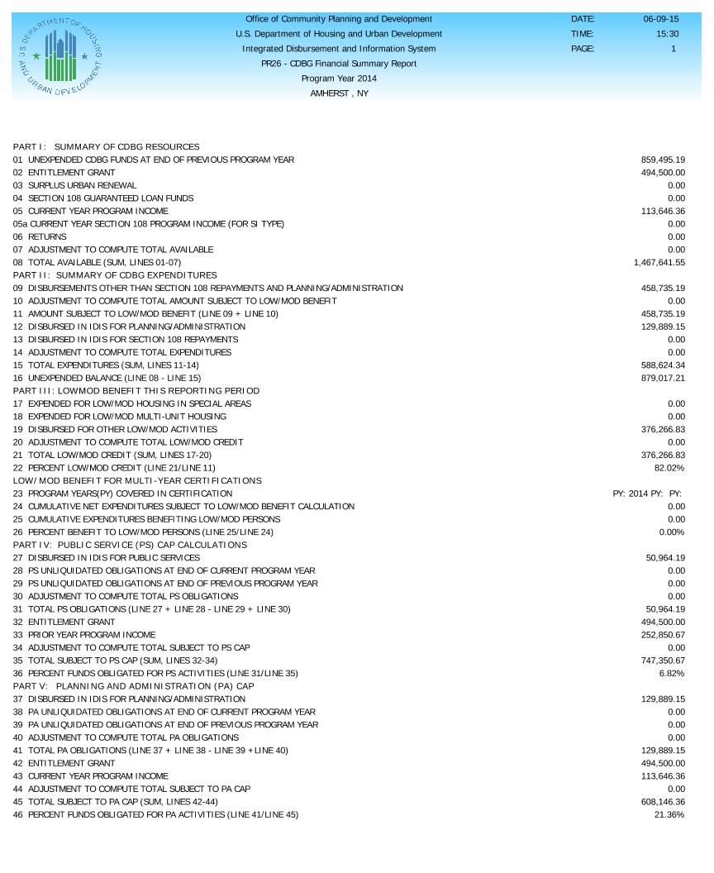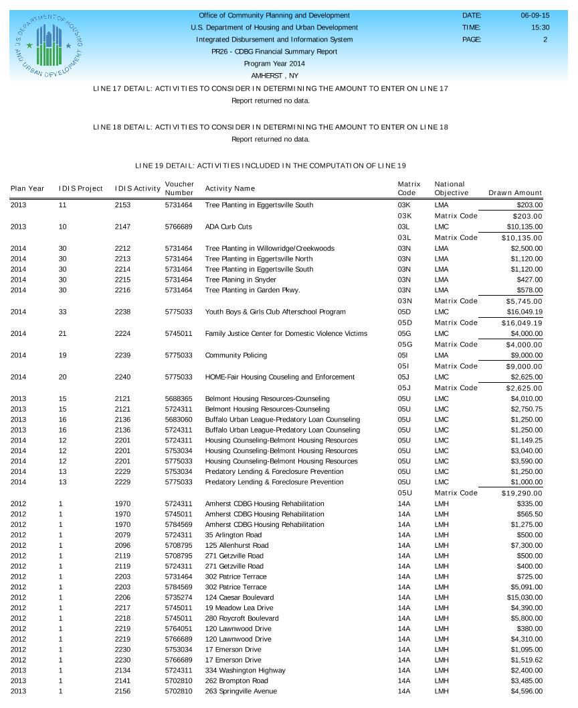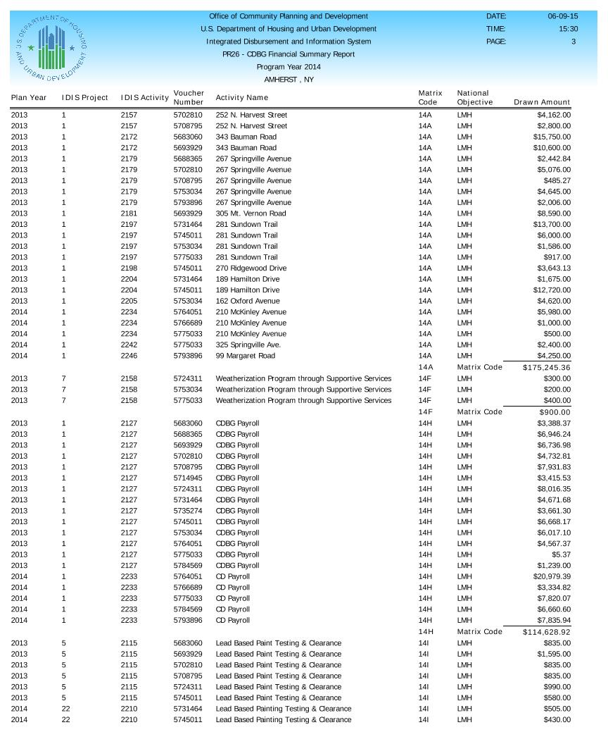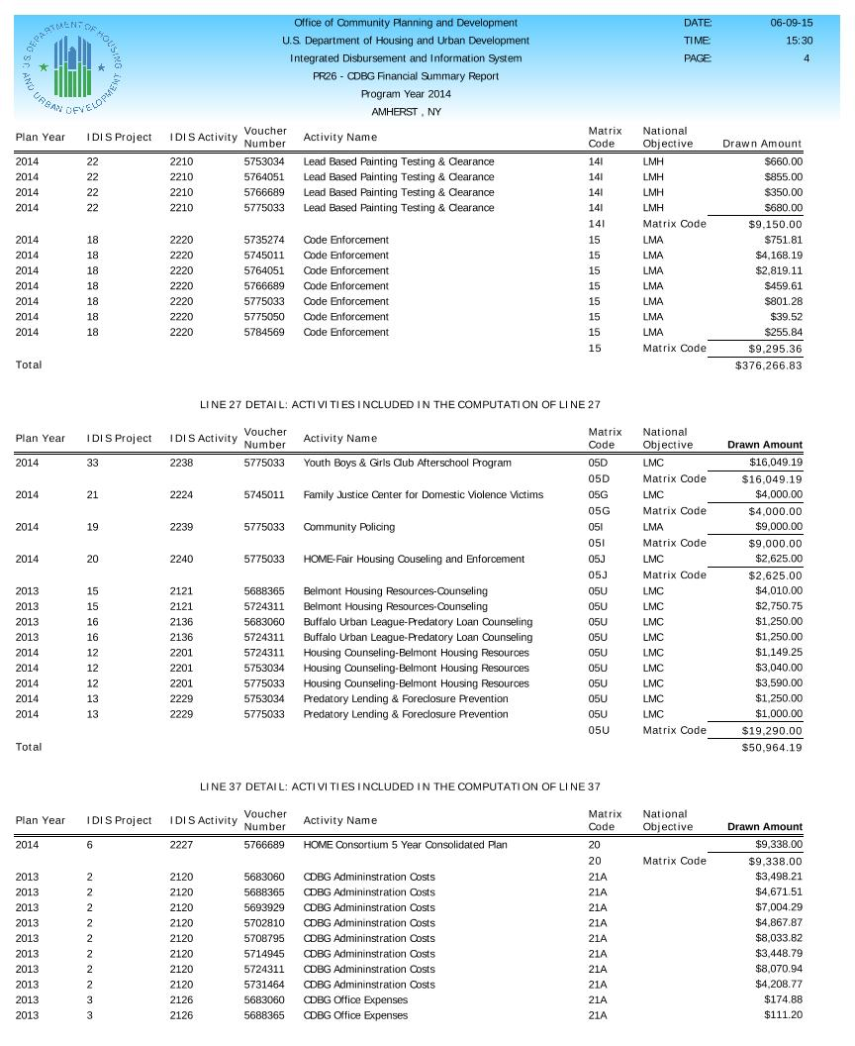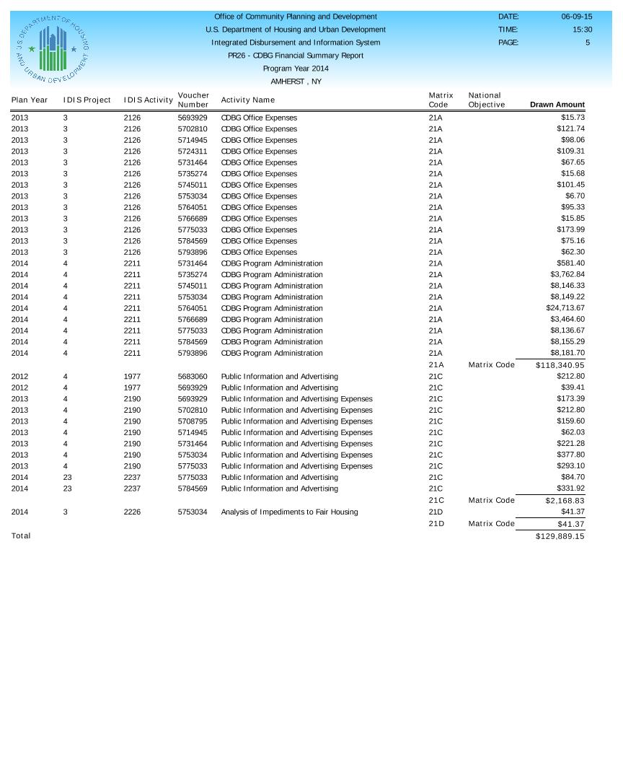

**PR06 2014 Projects**

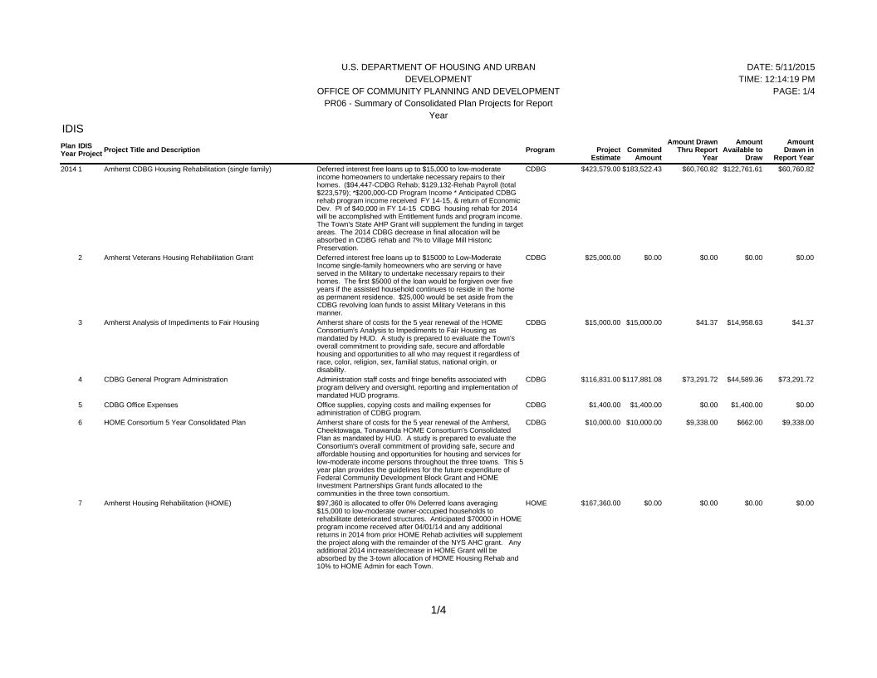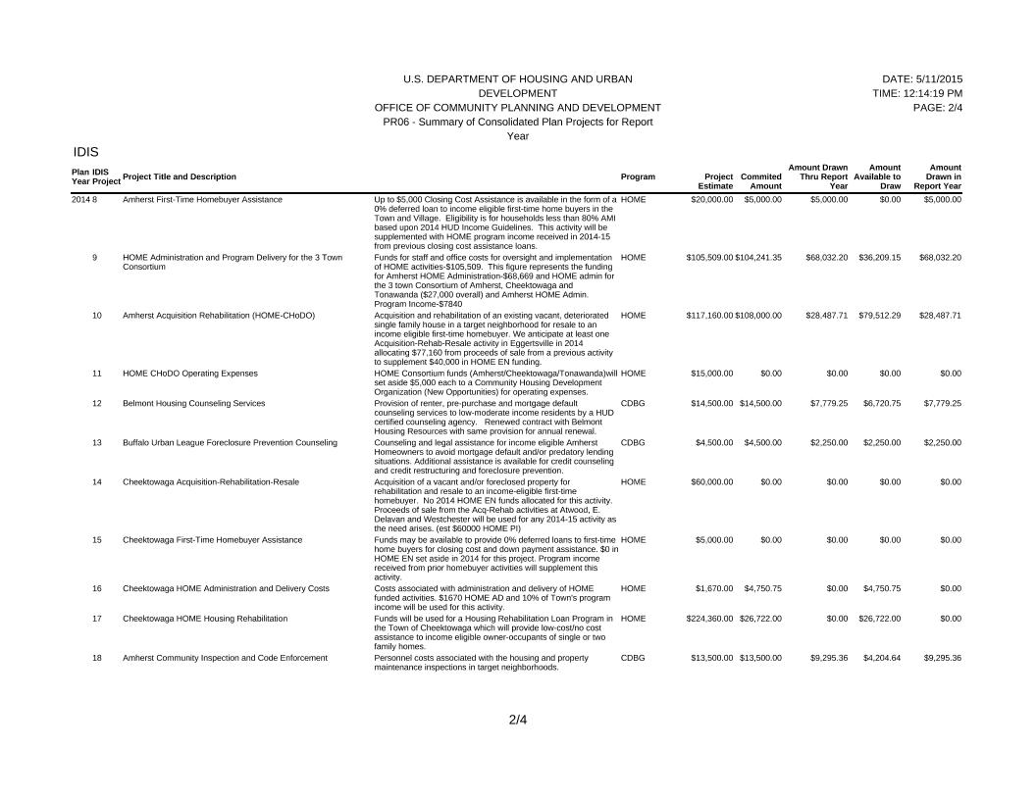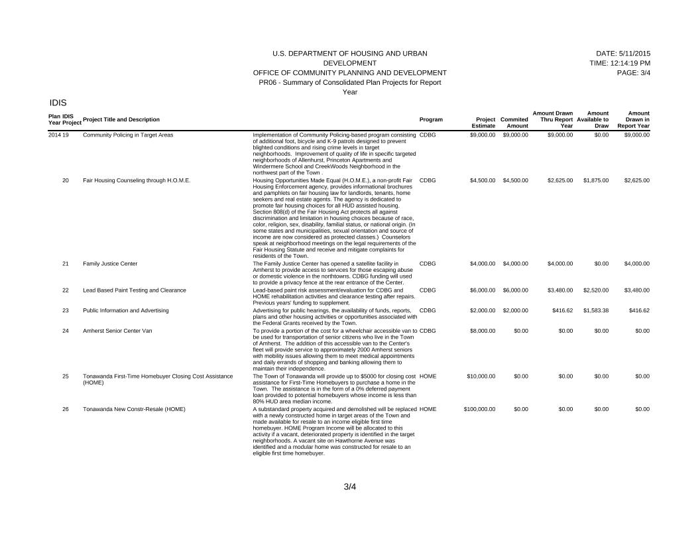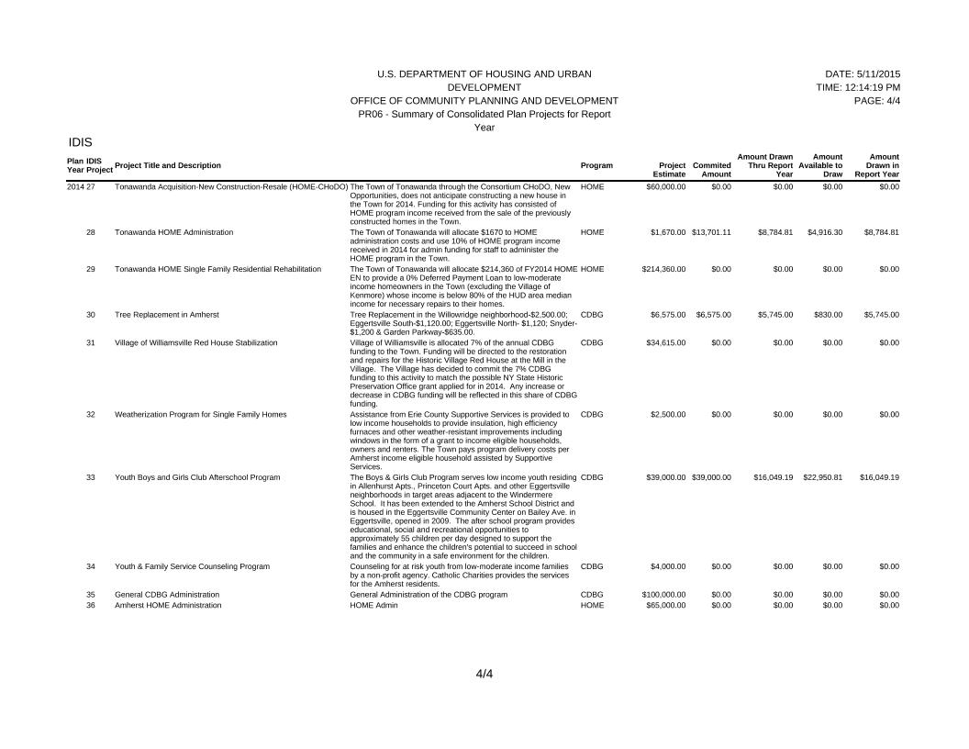

**PR23 HOME Accomplishments Summary**

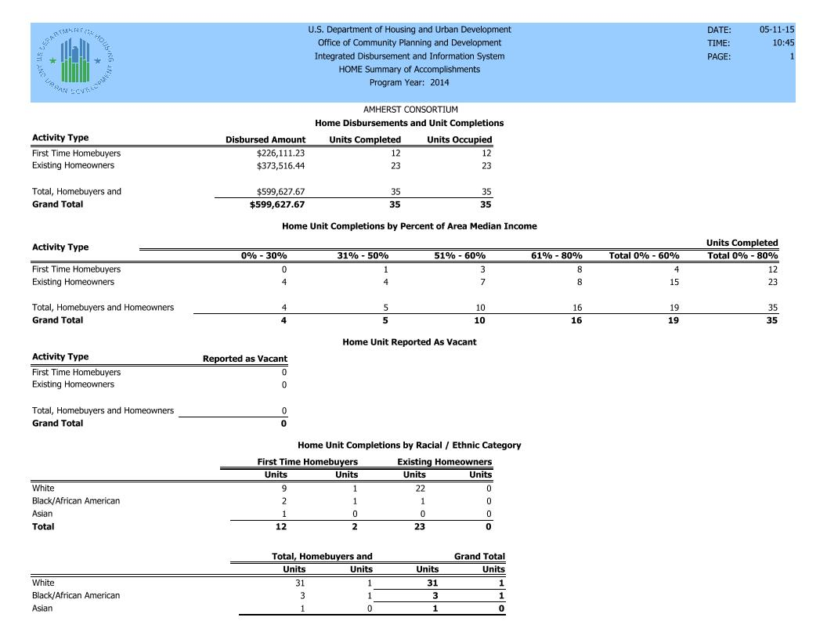

**PR03 CDBG Activities 2014**

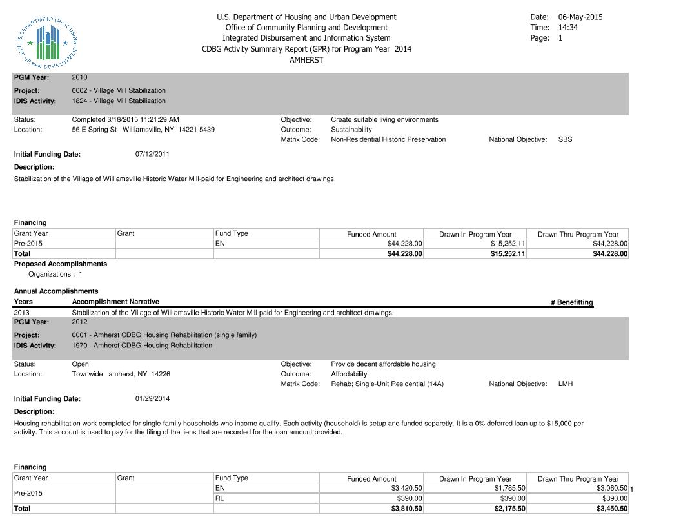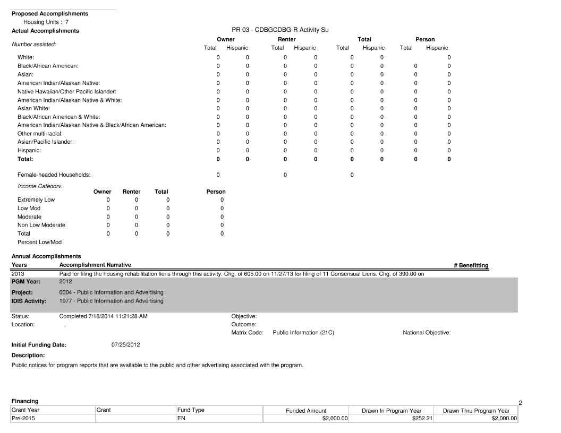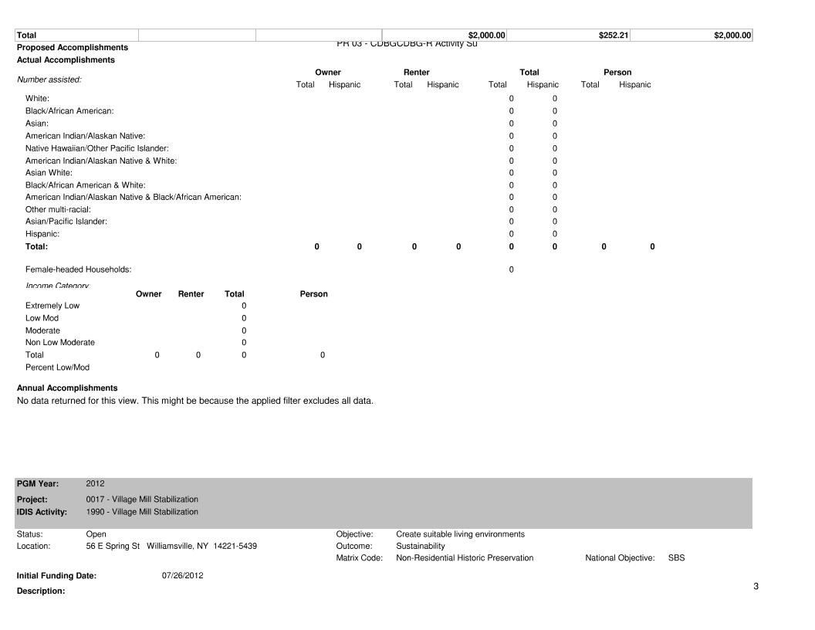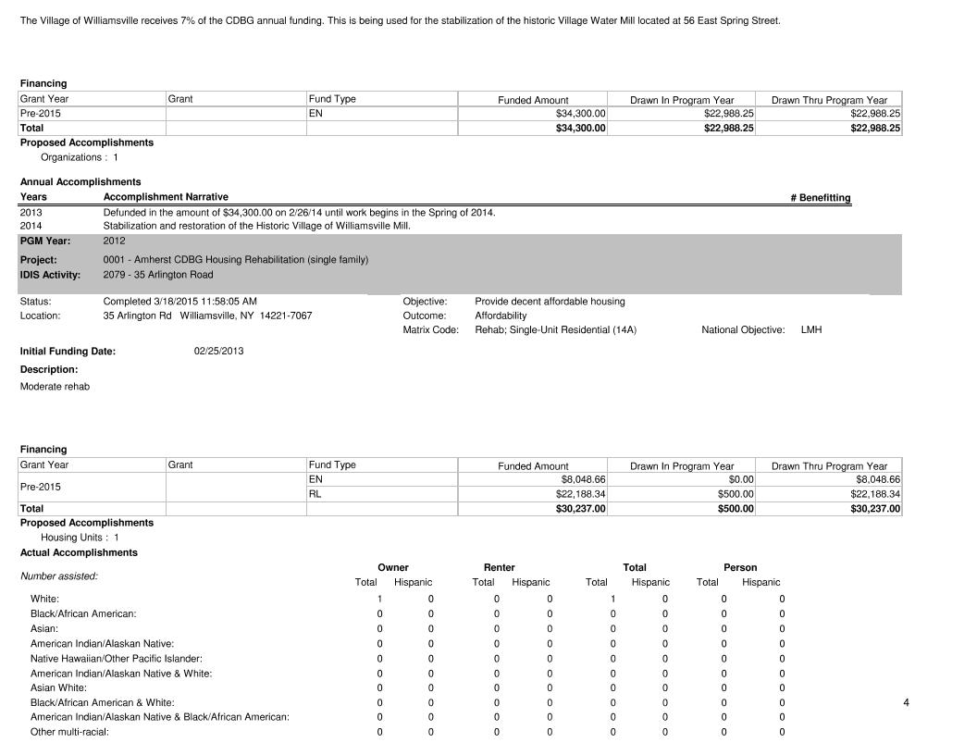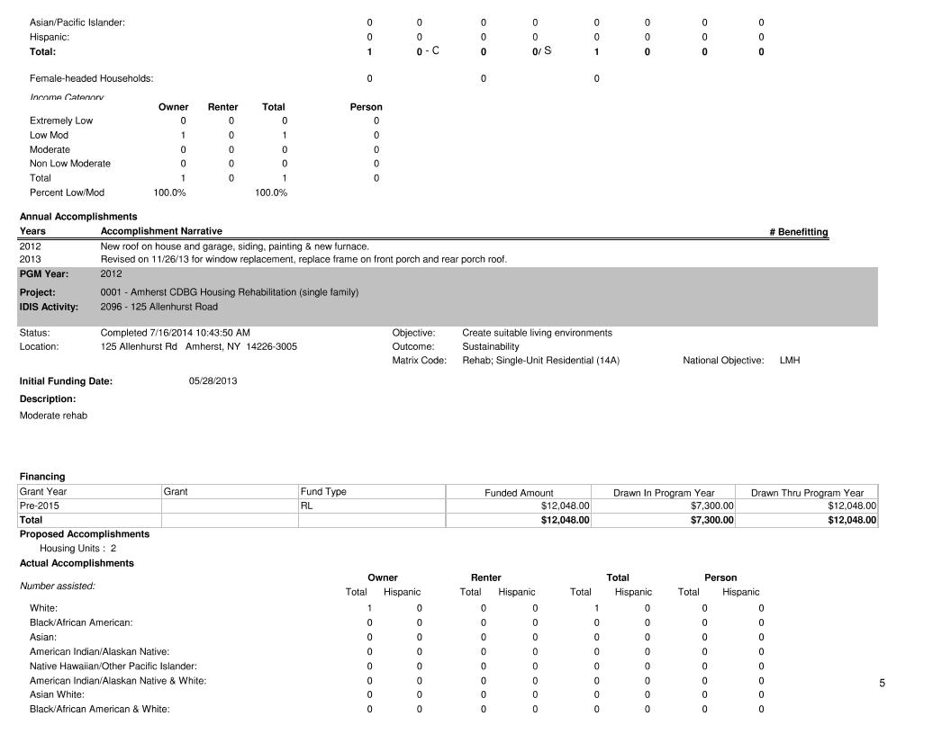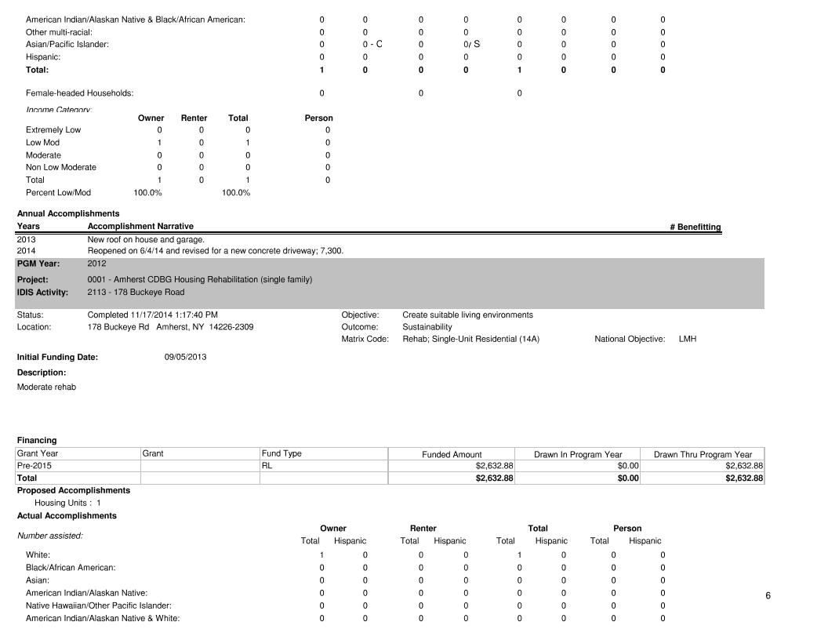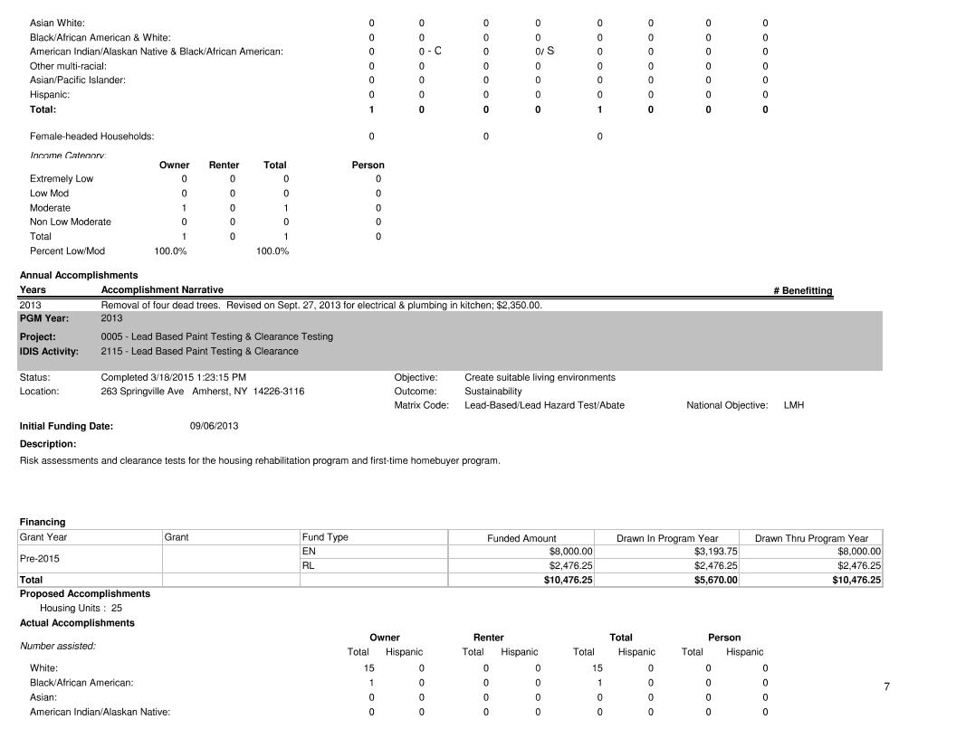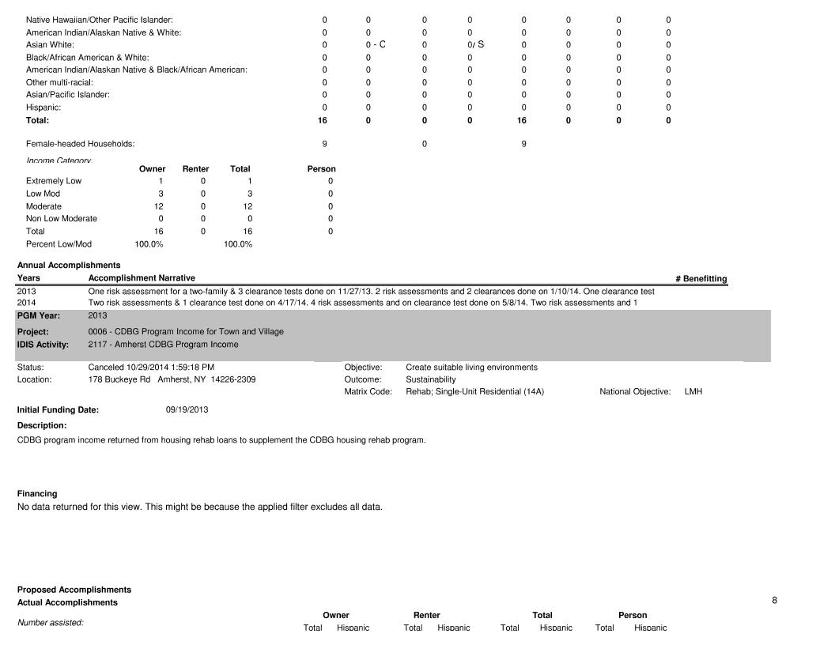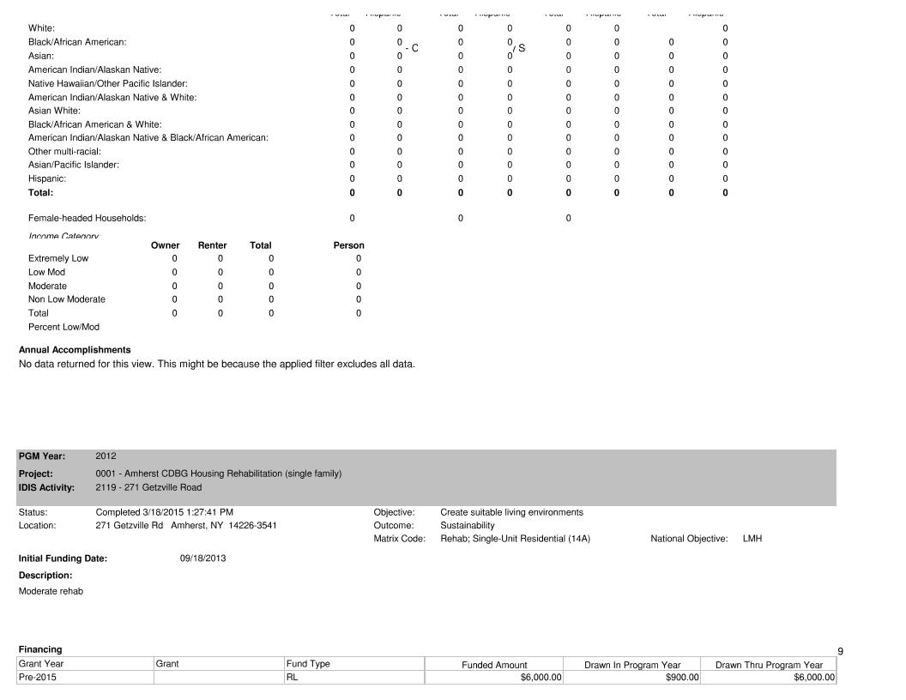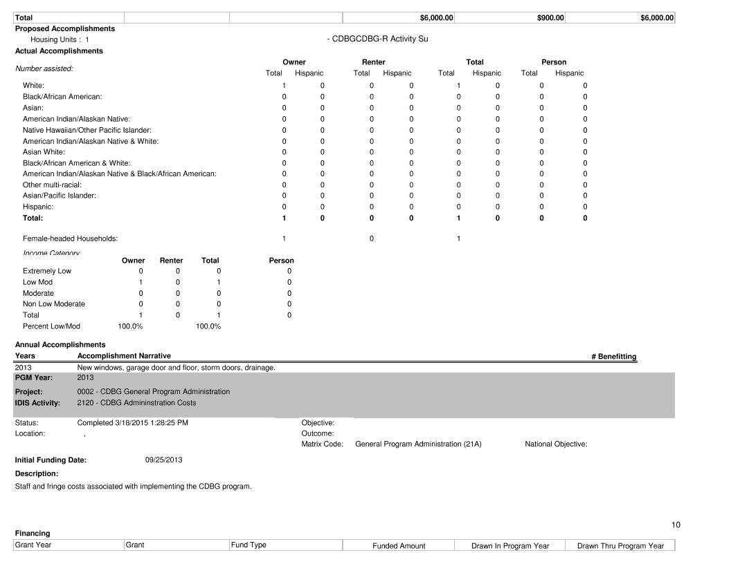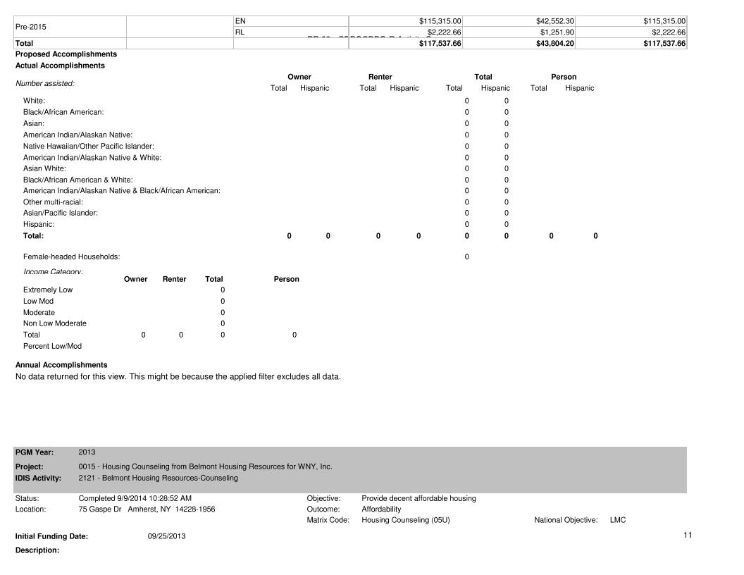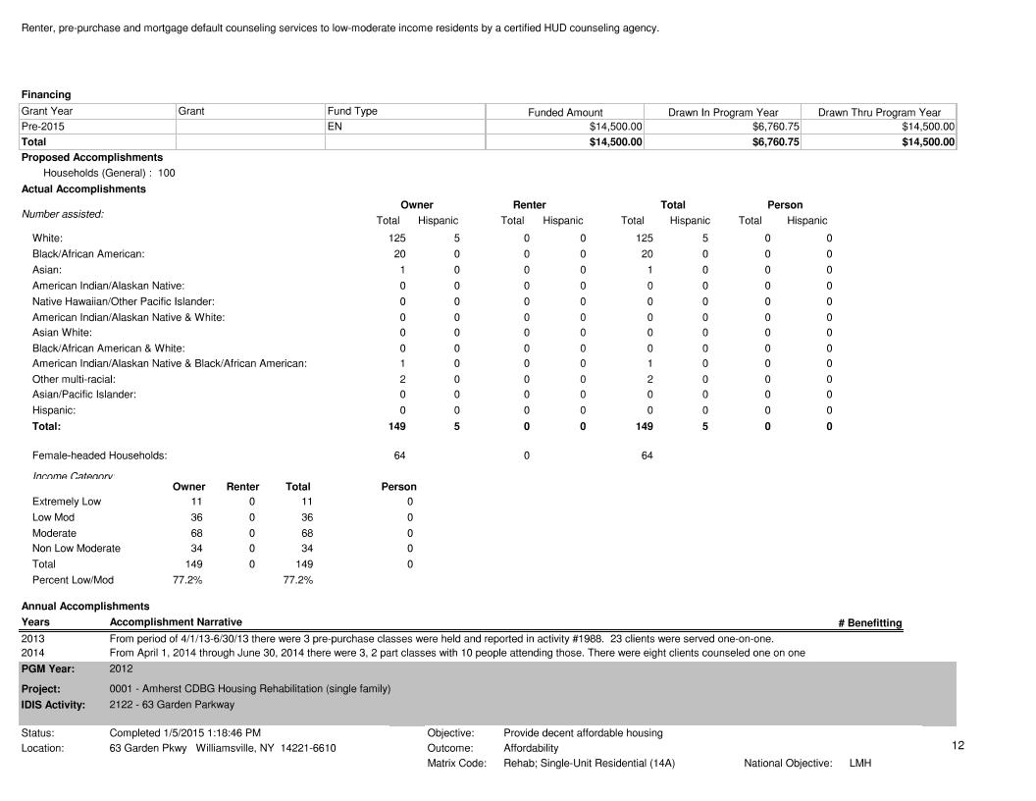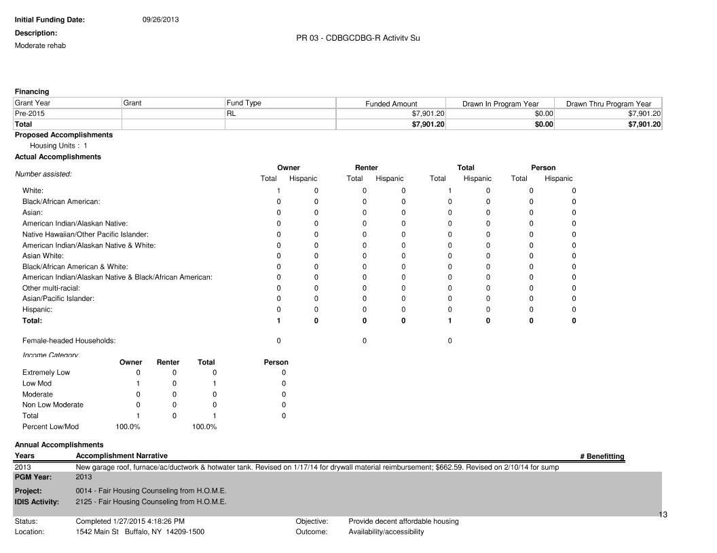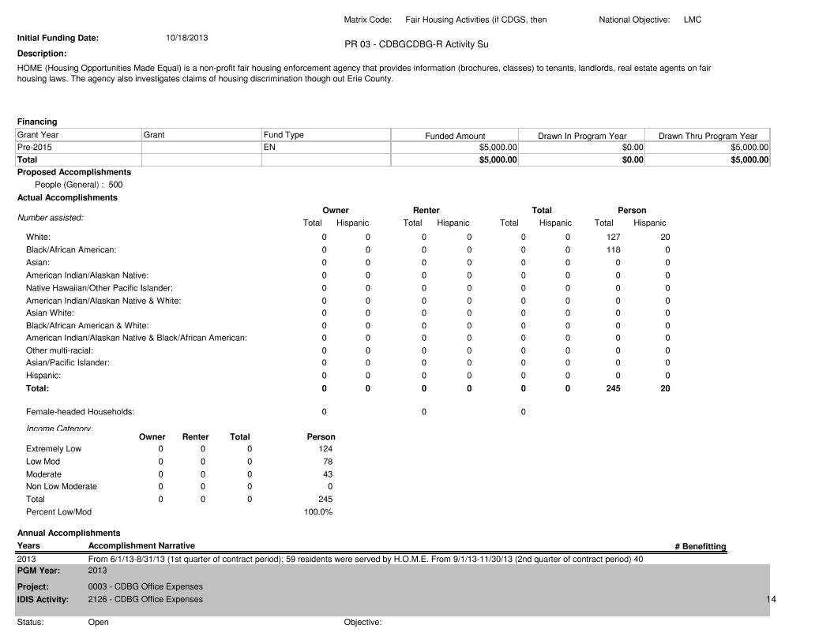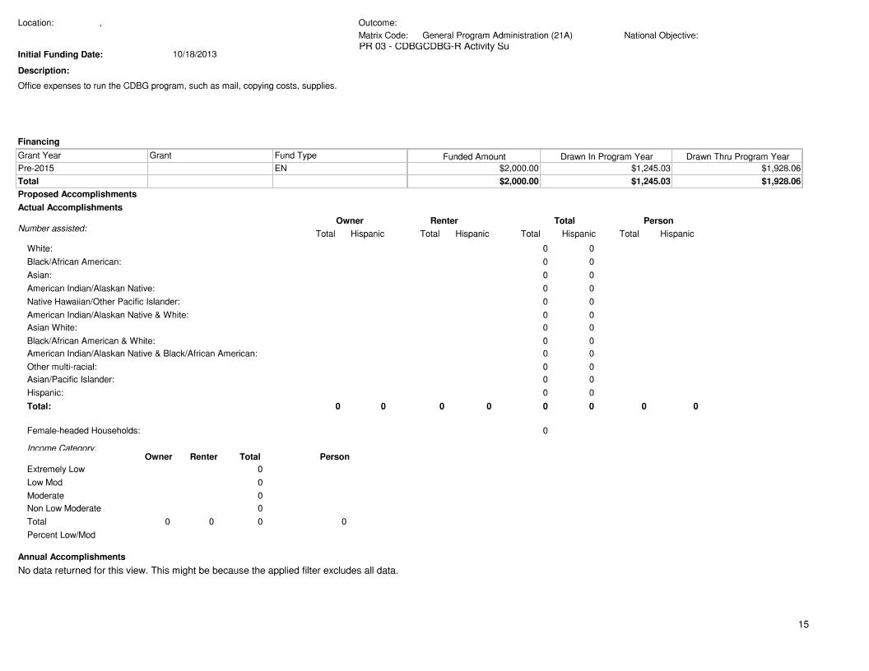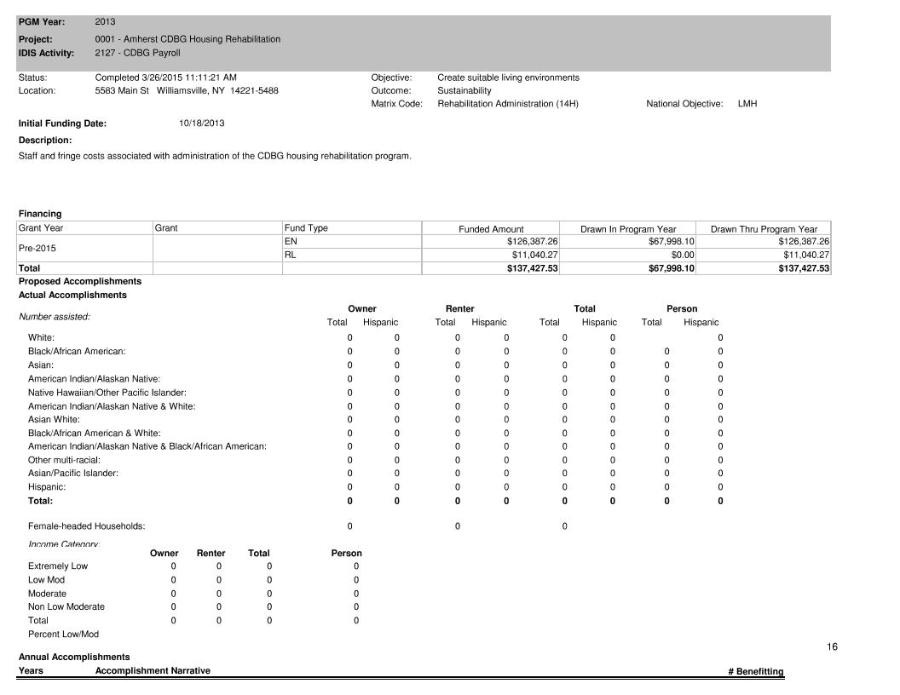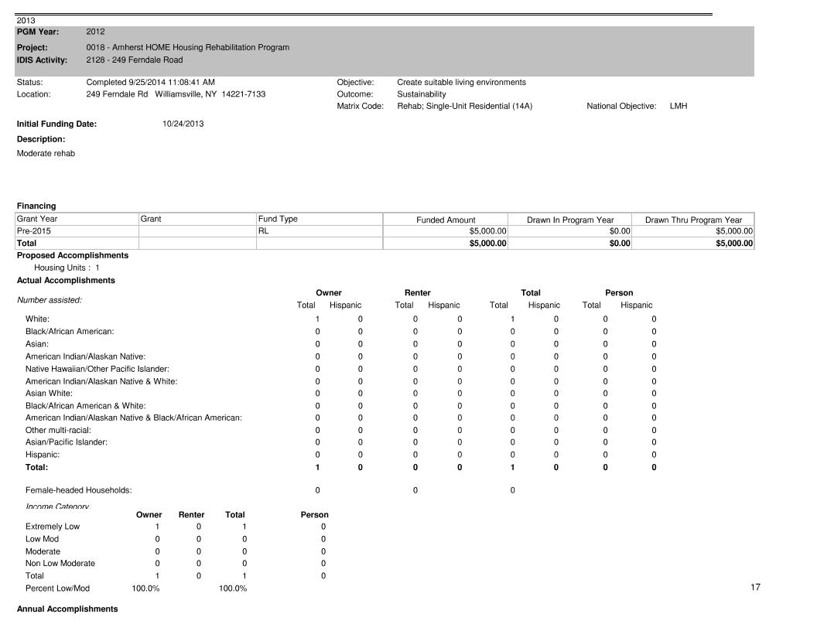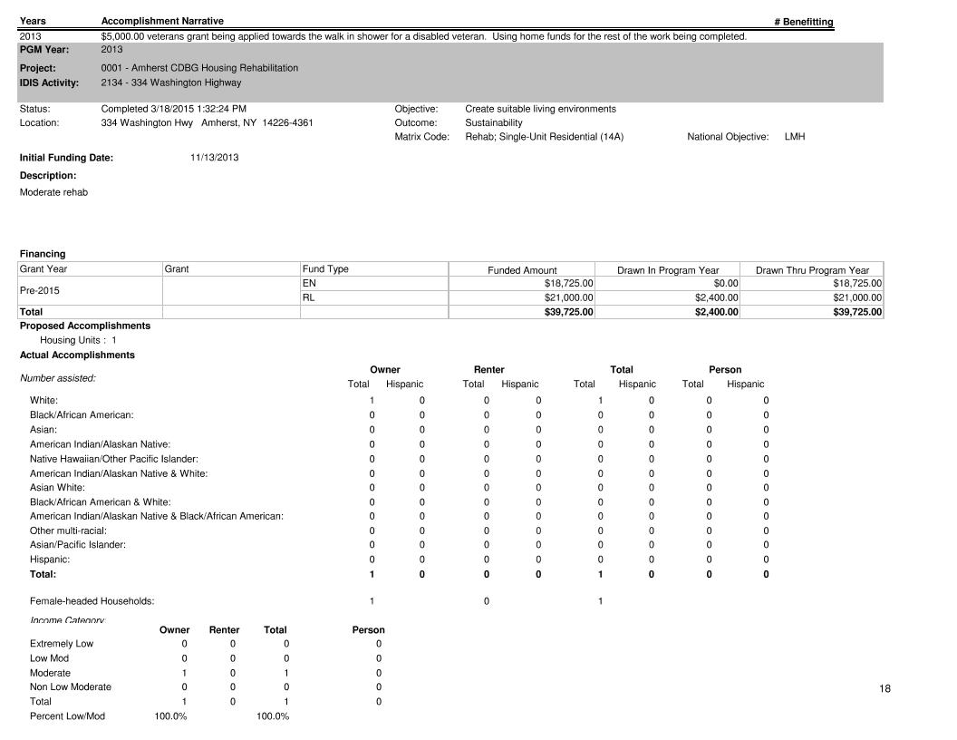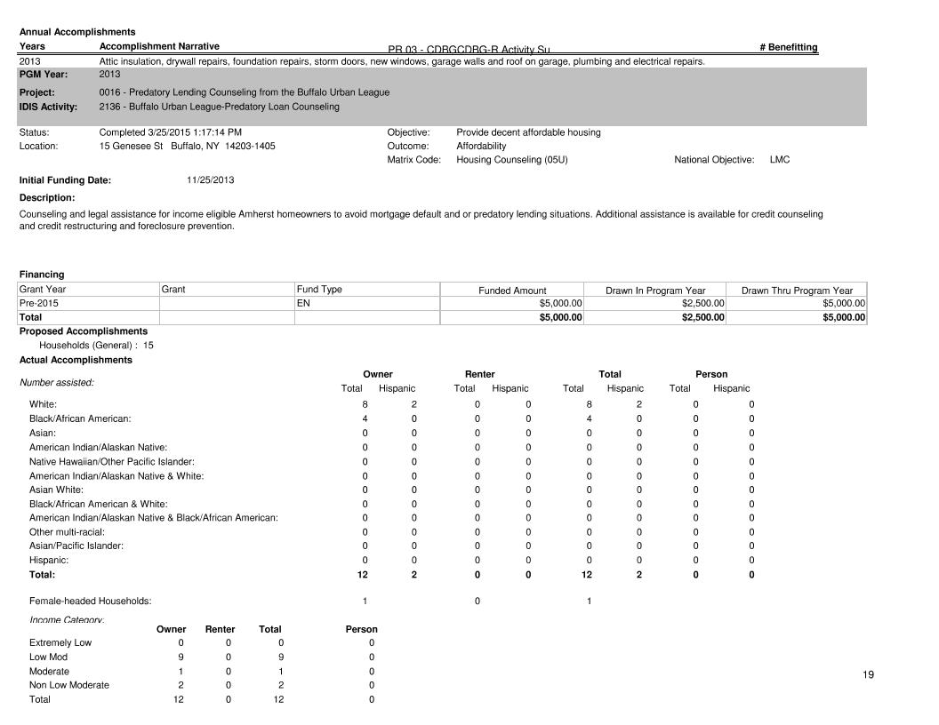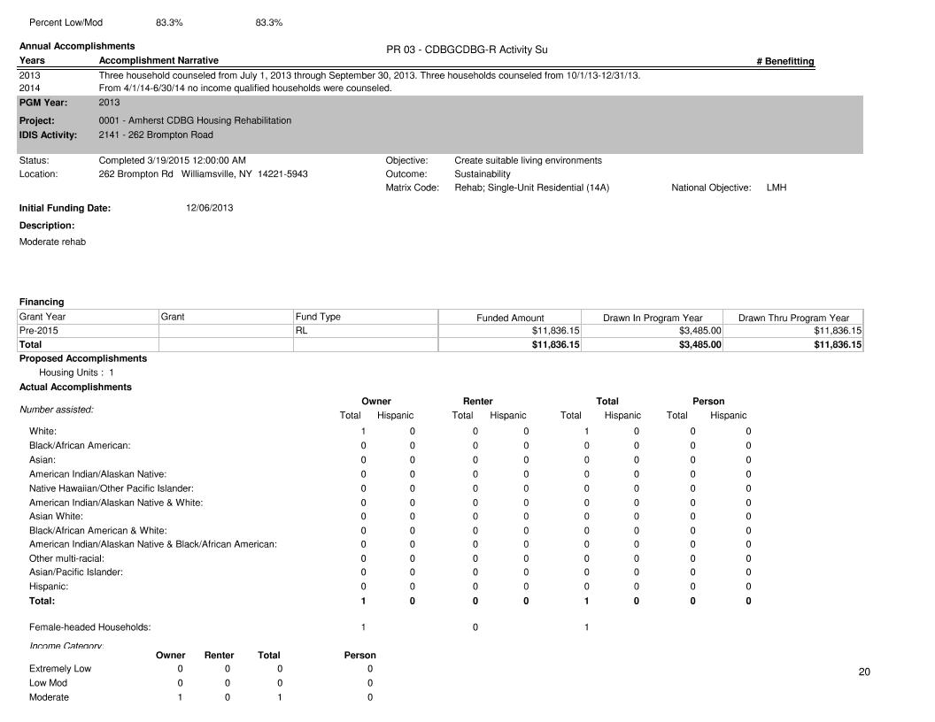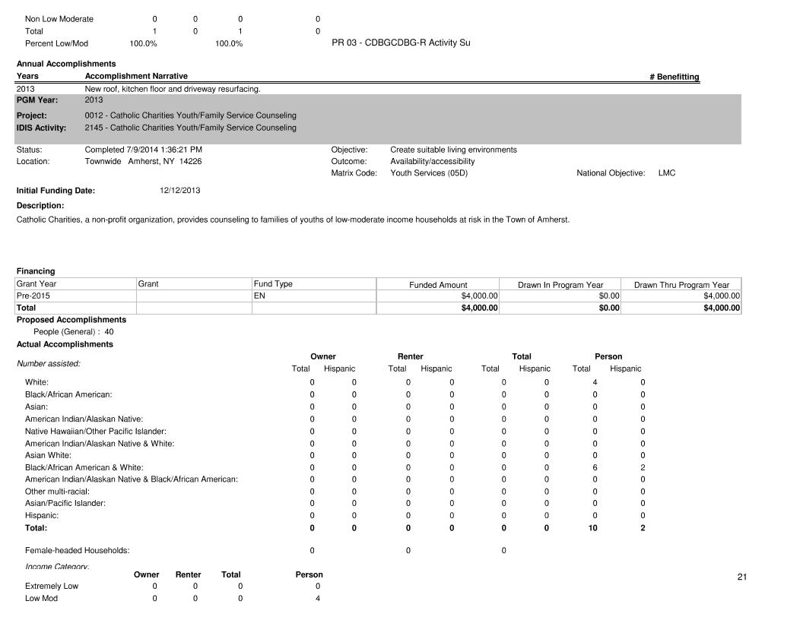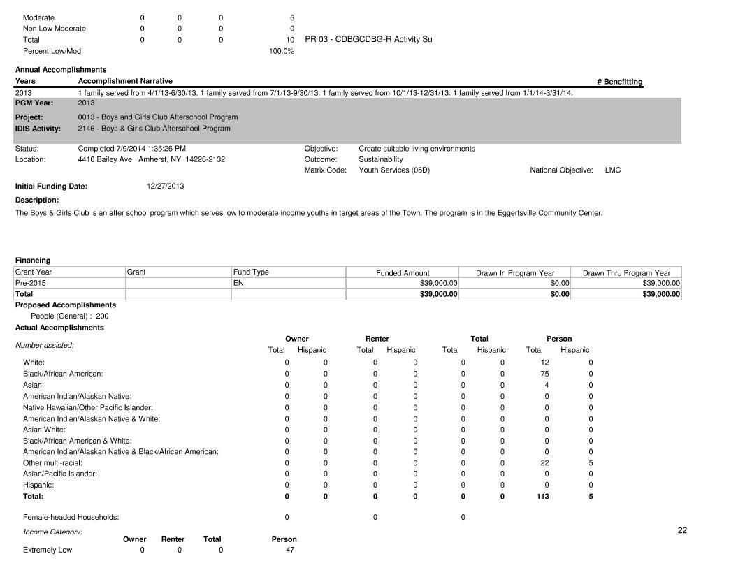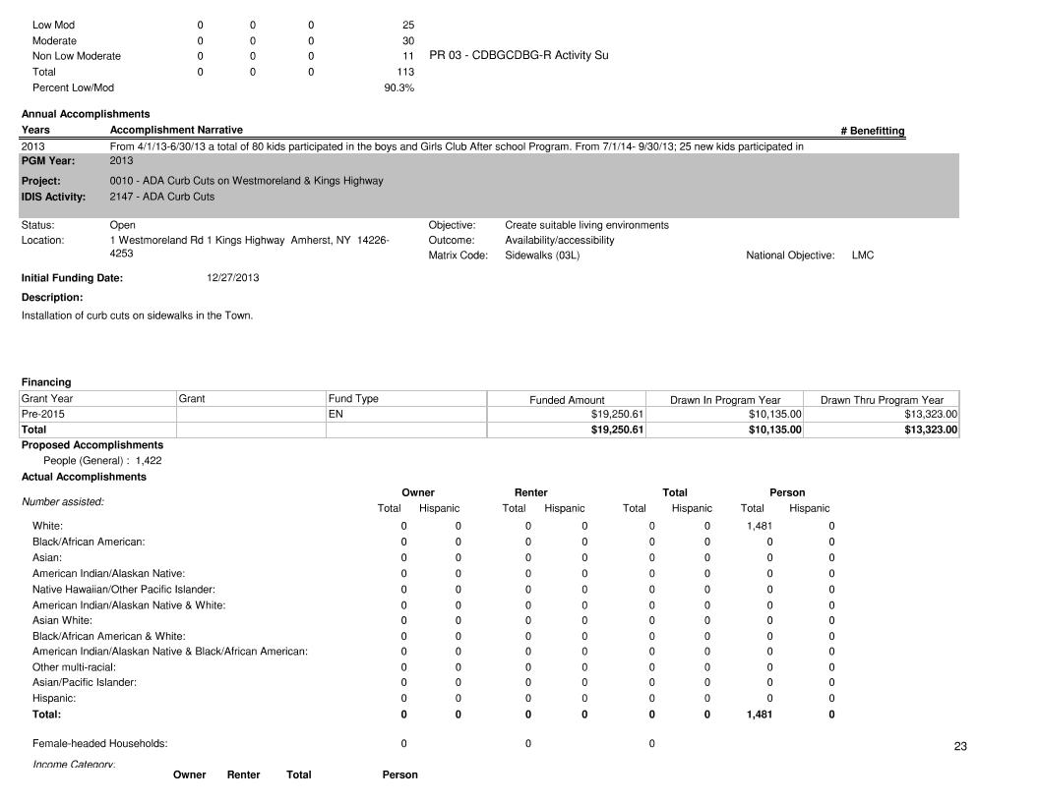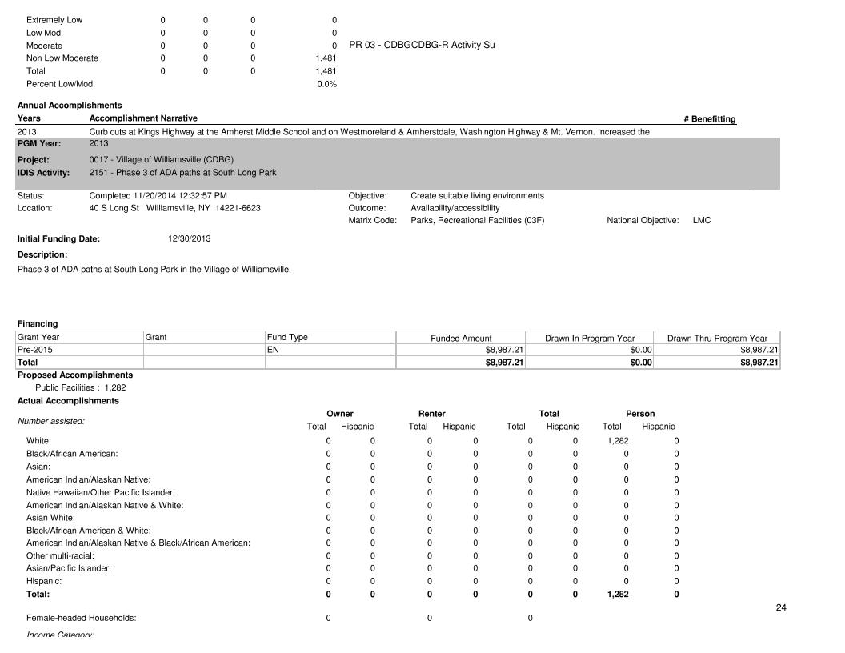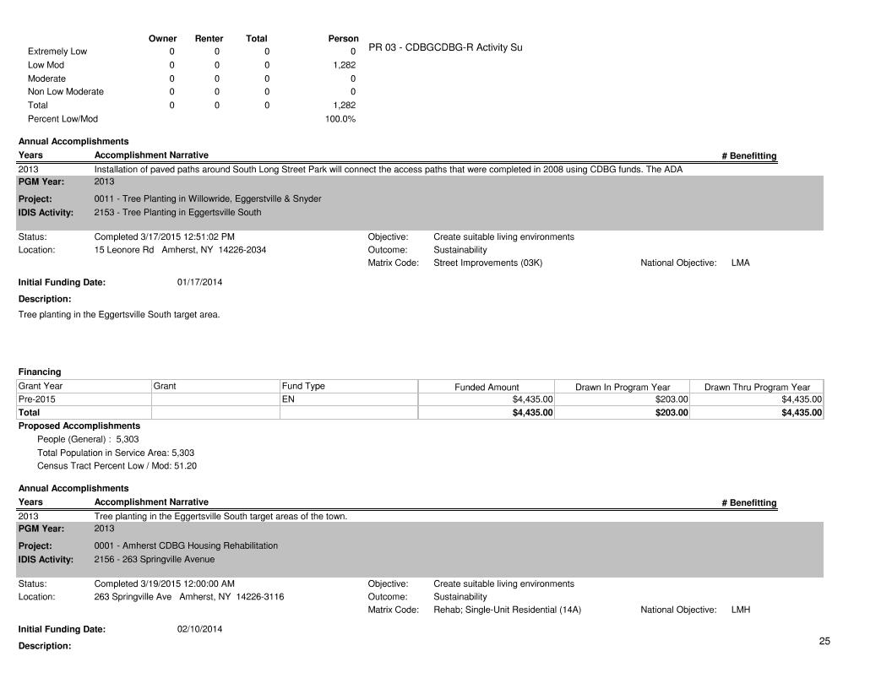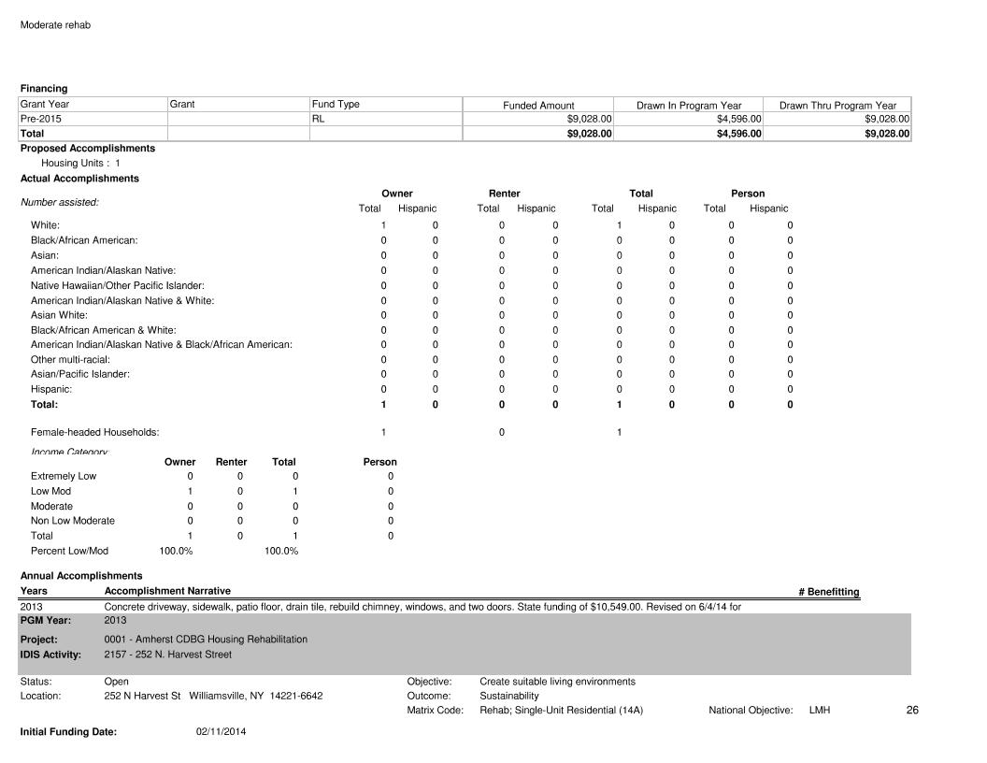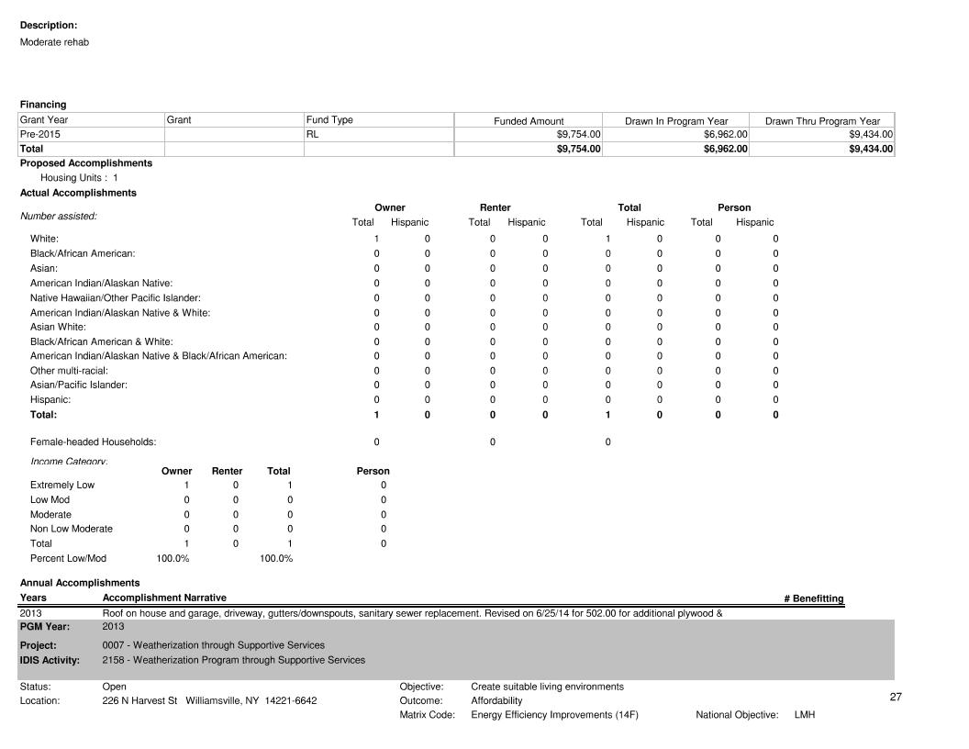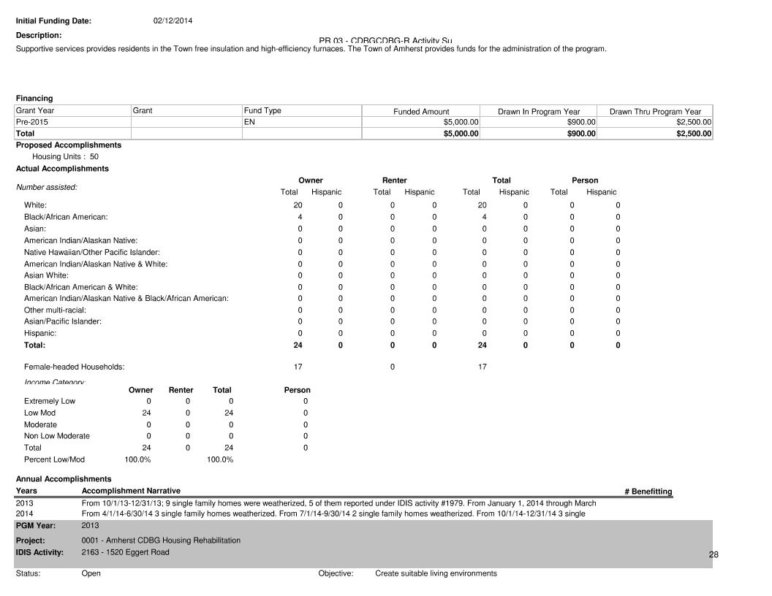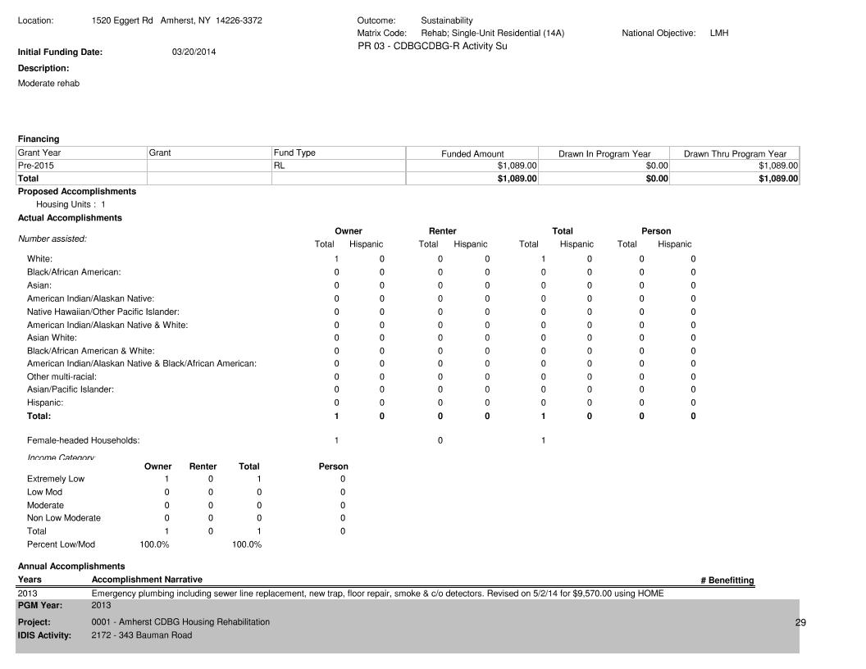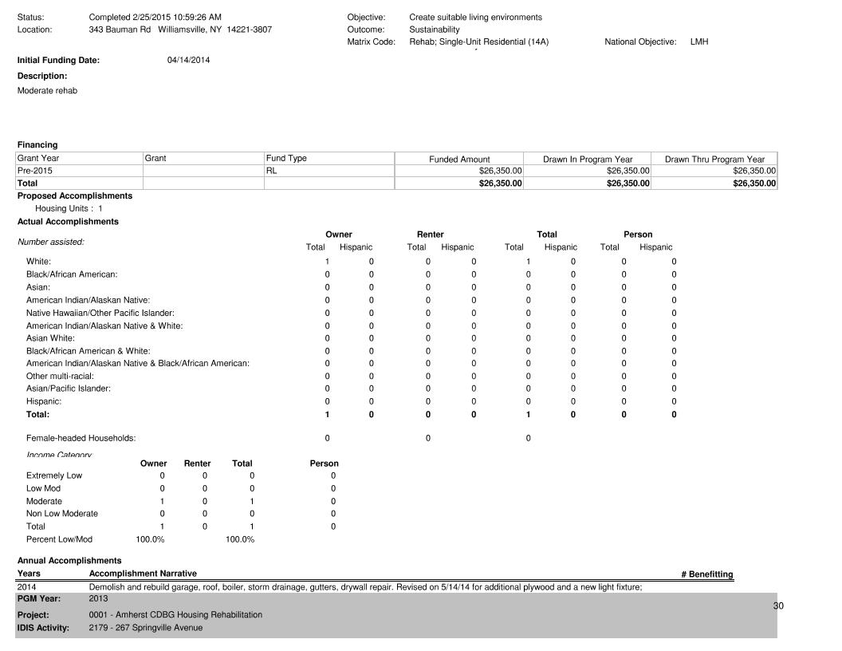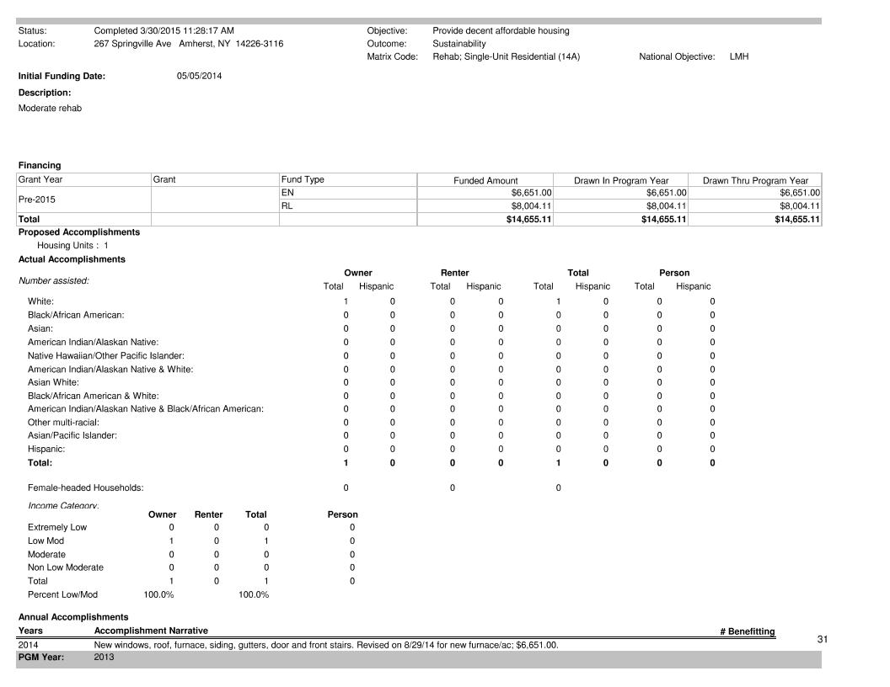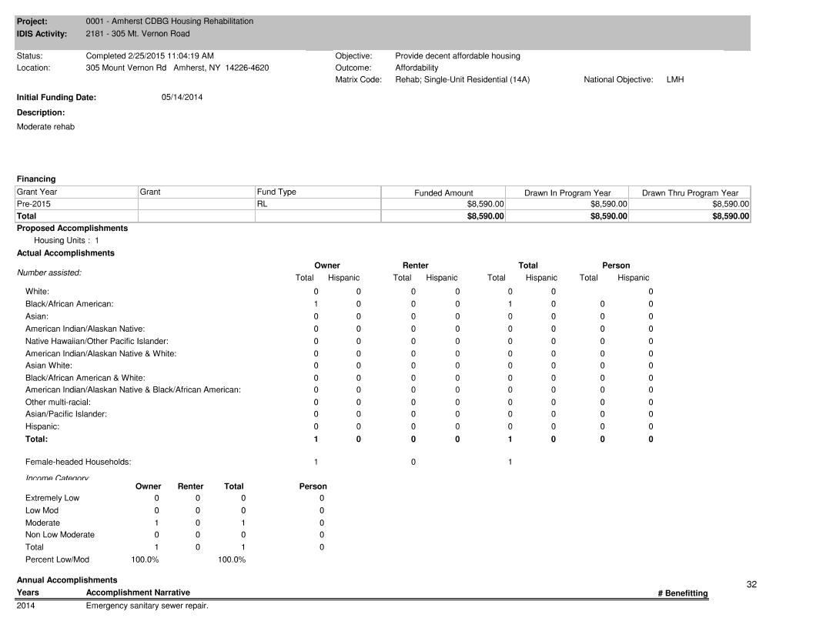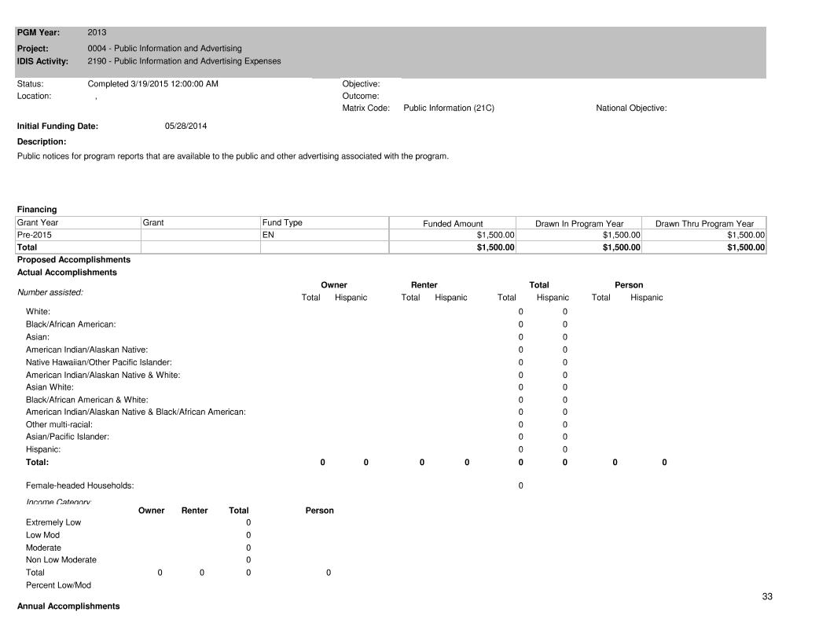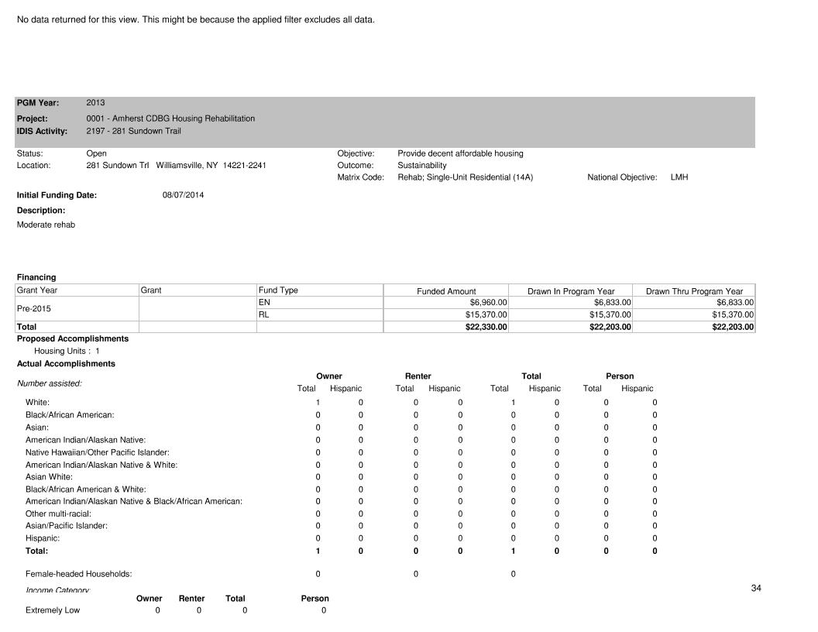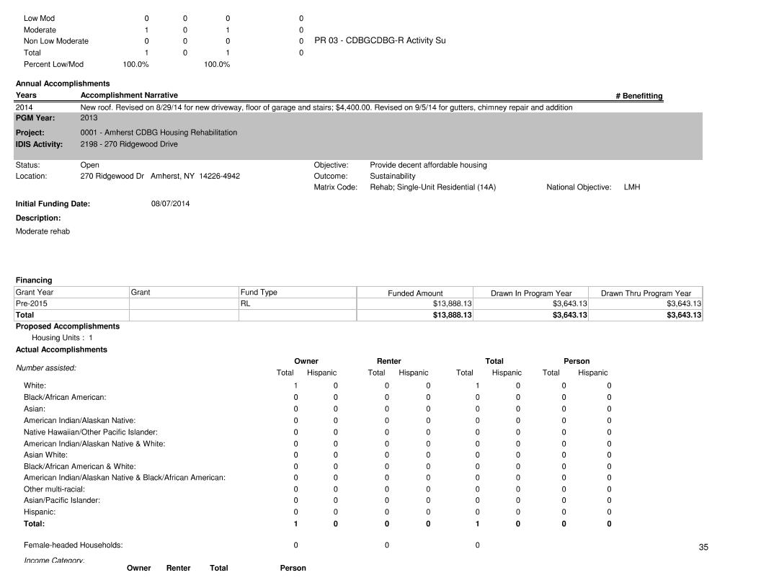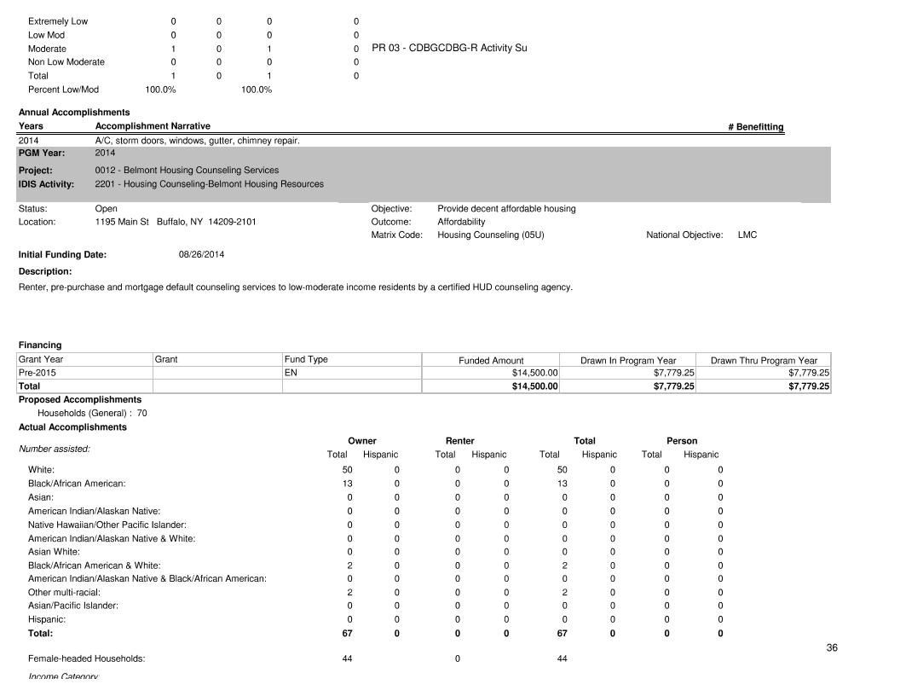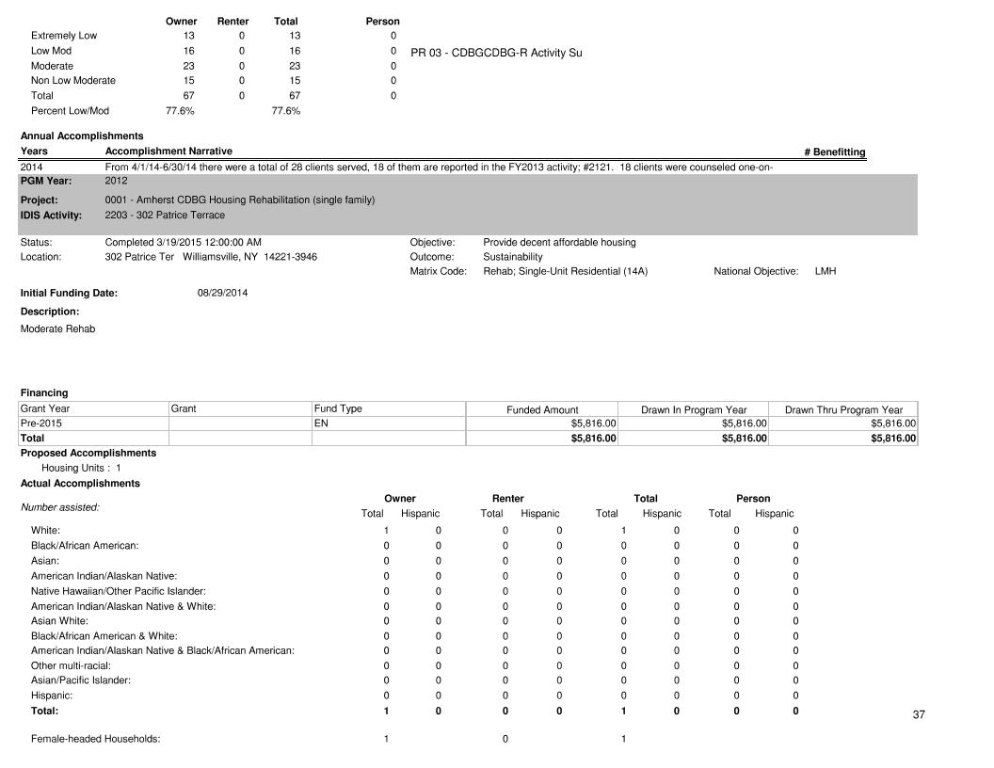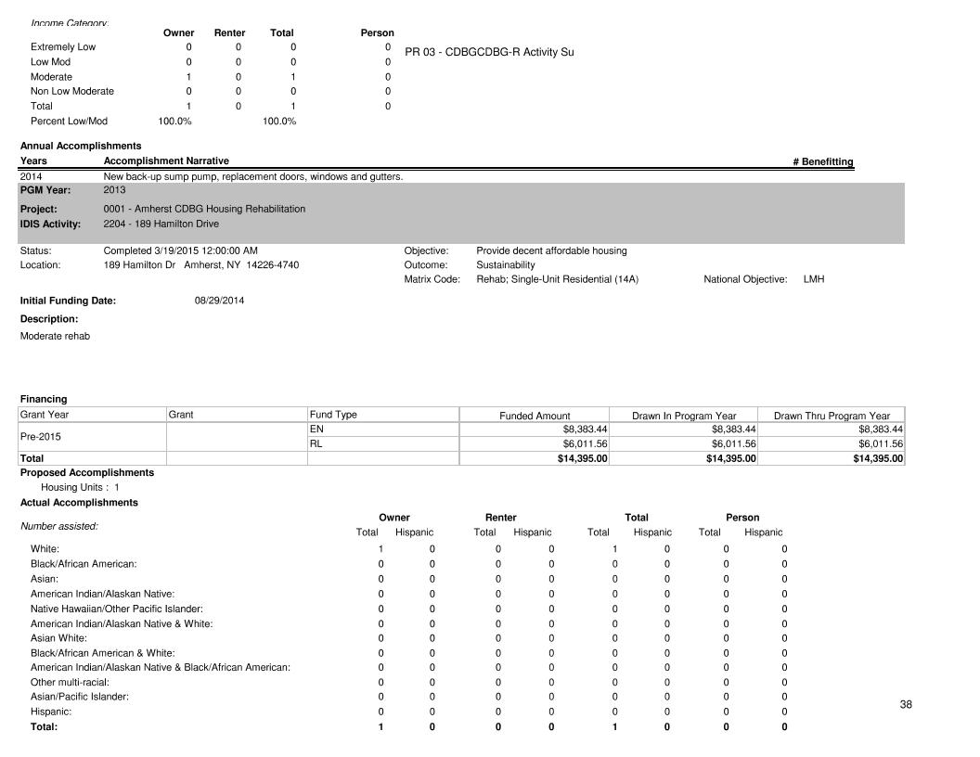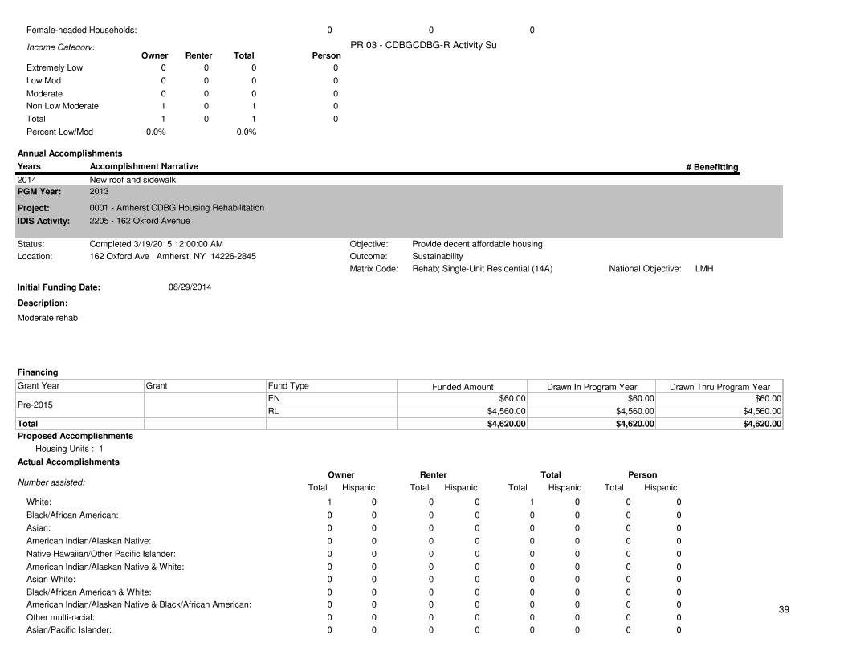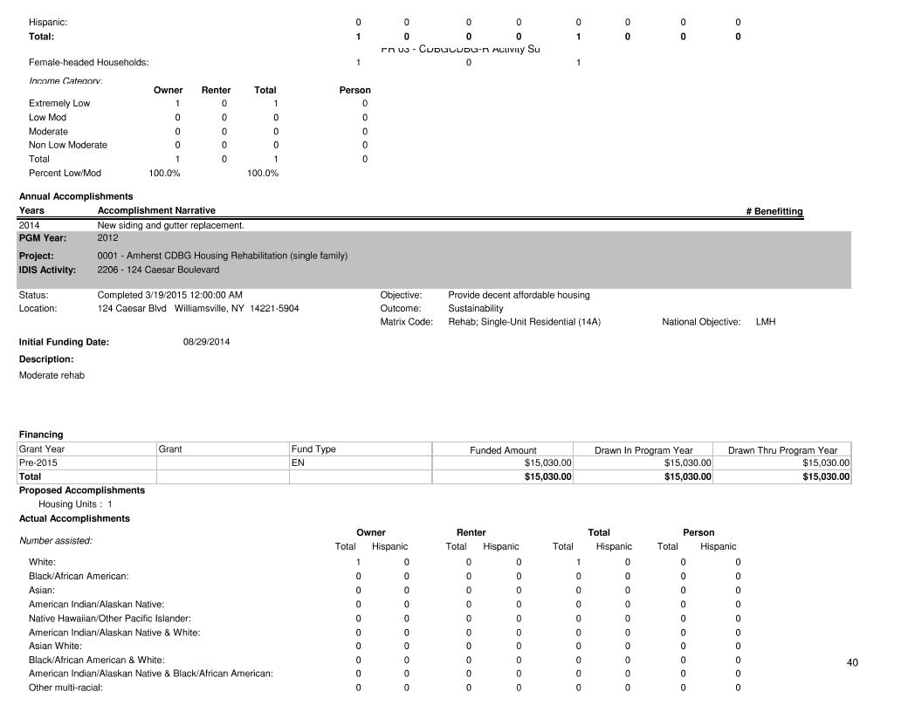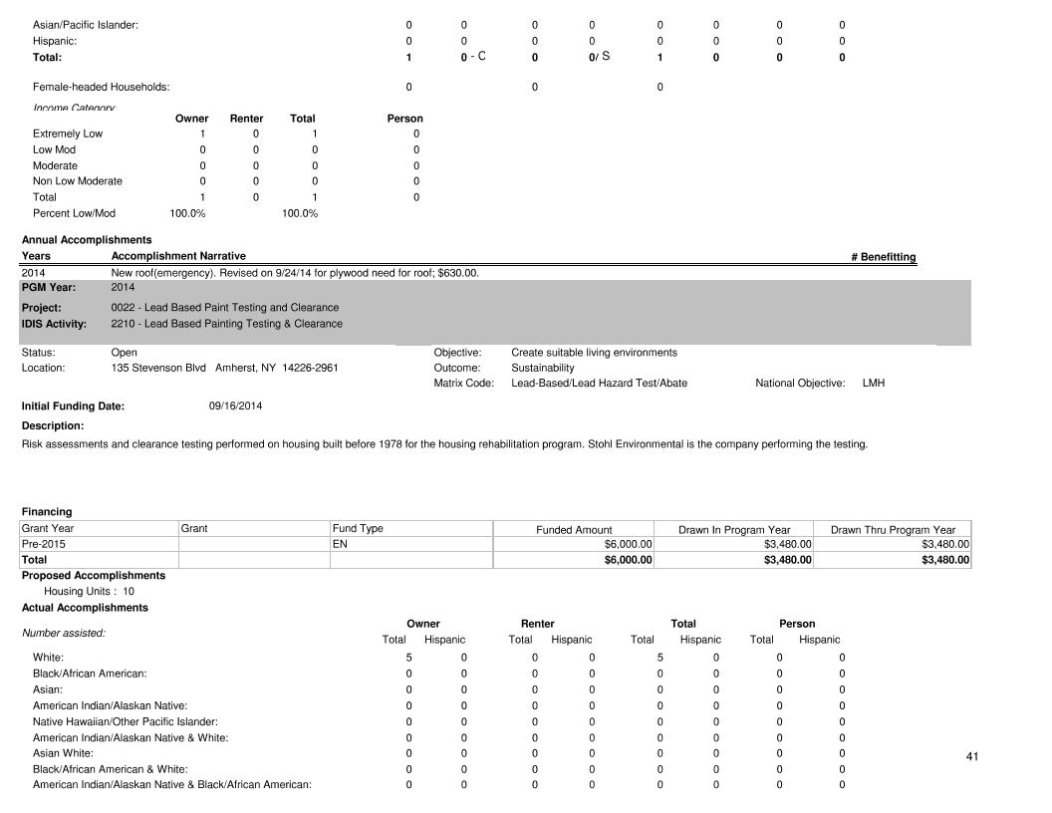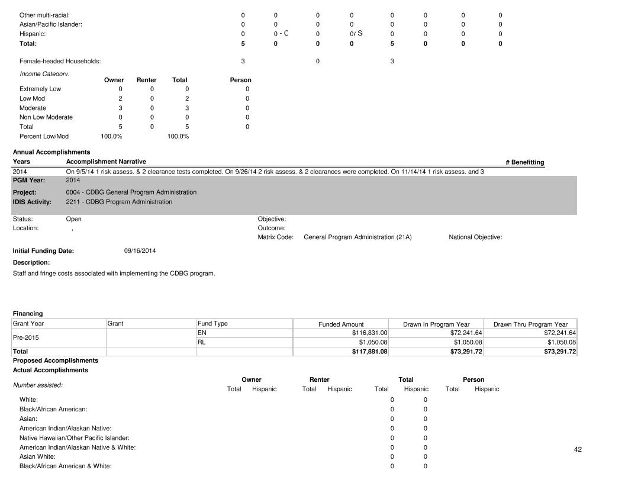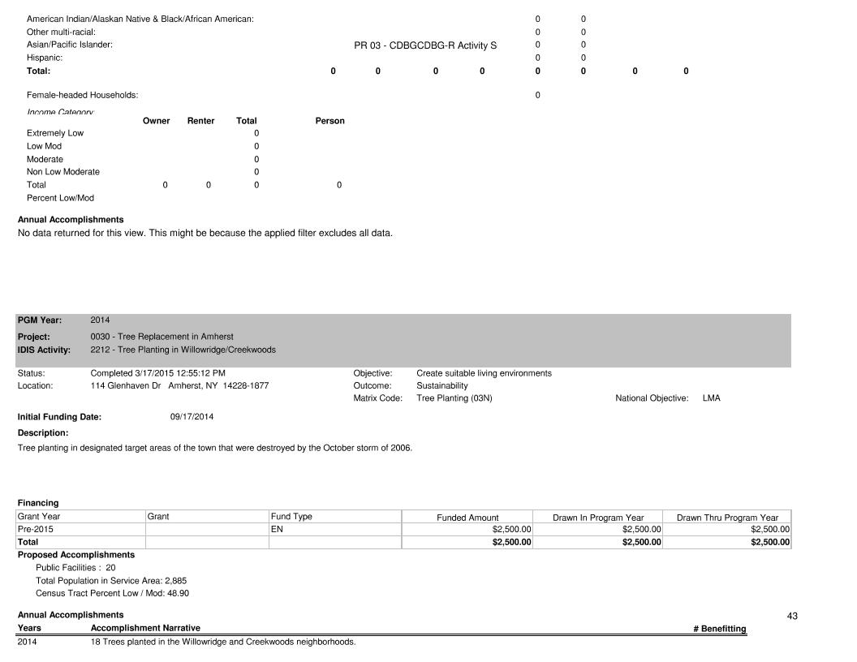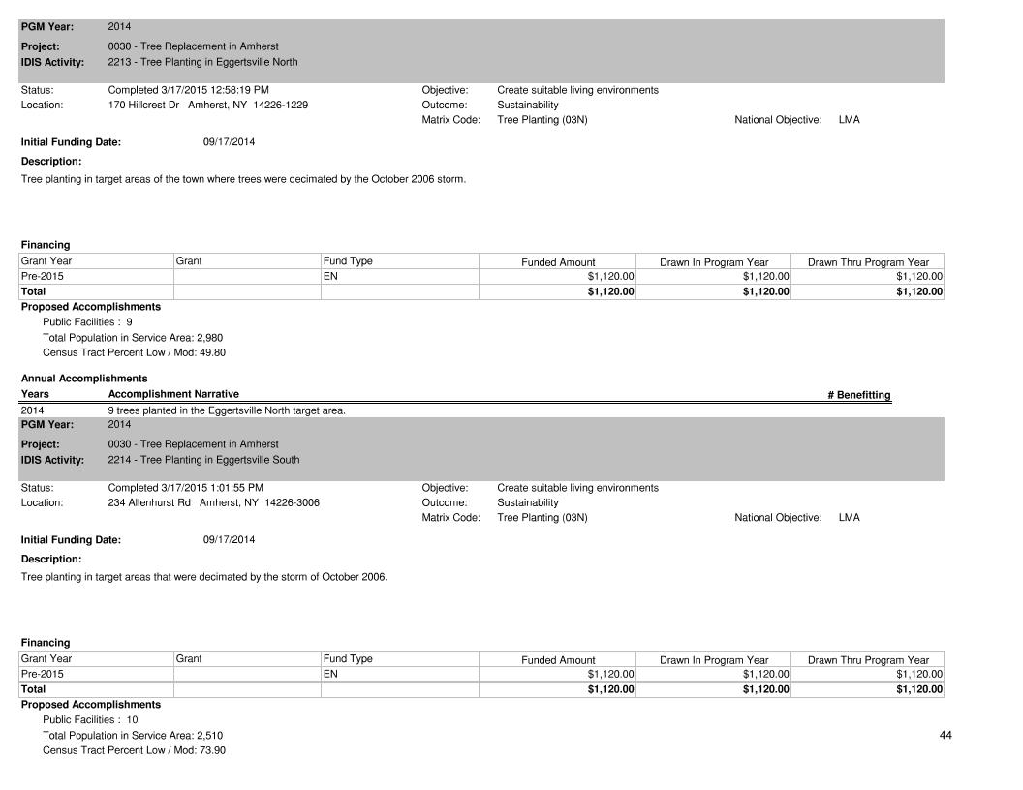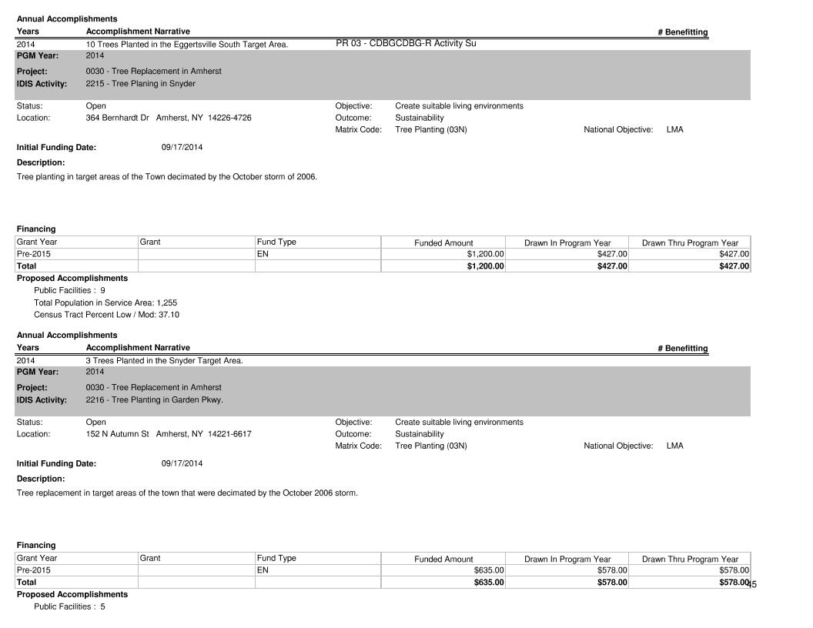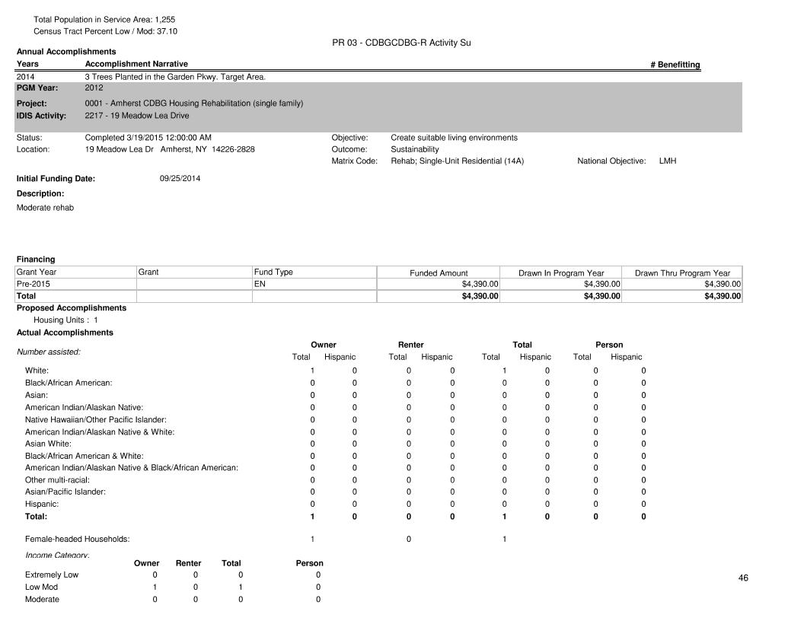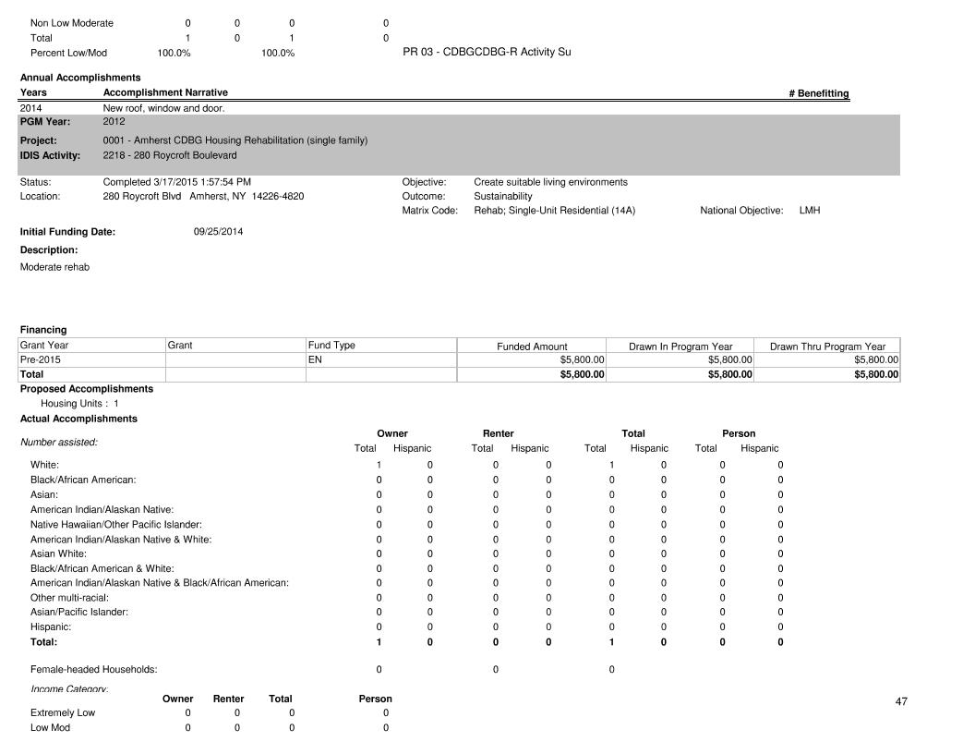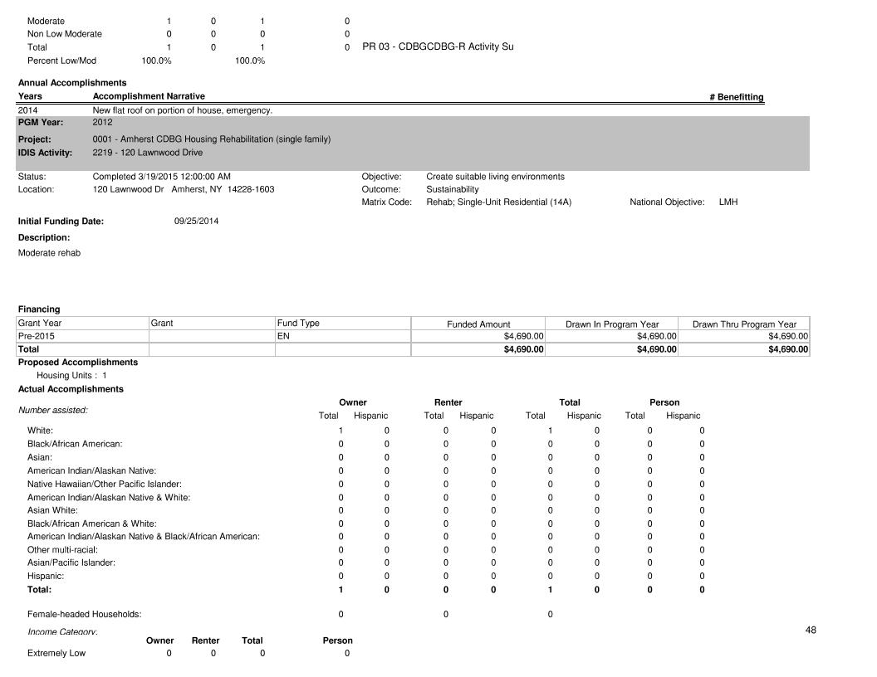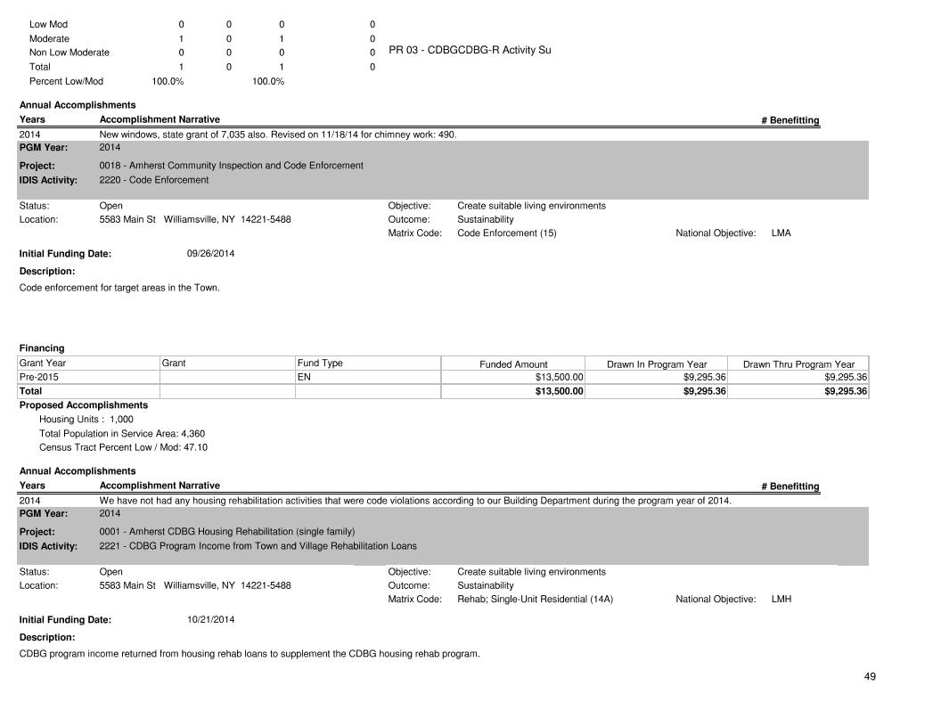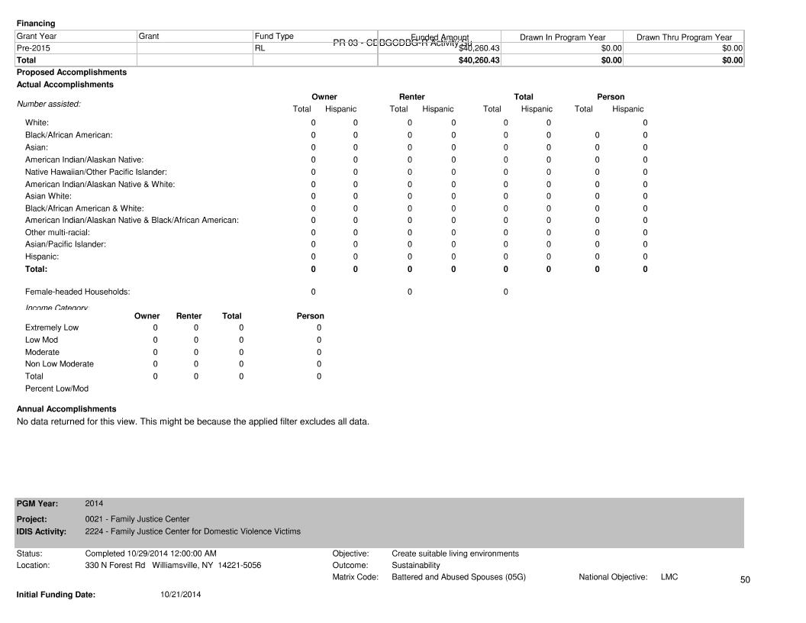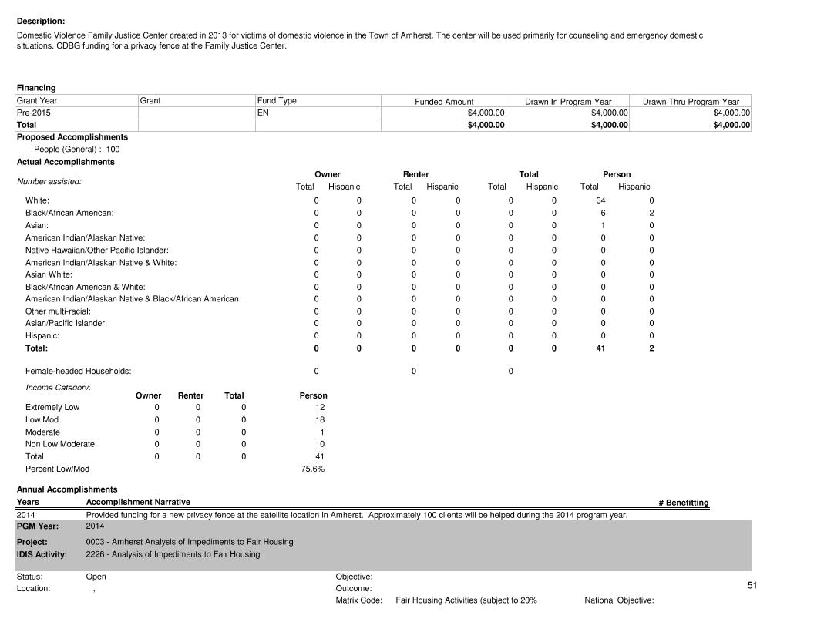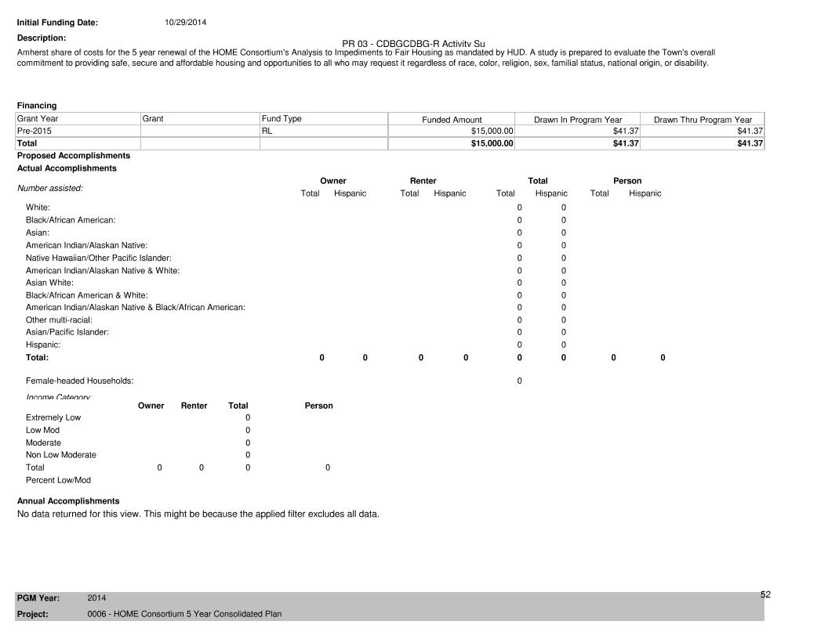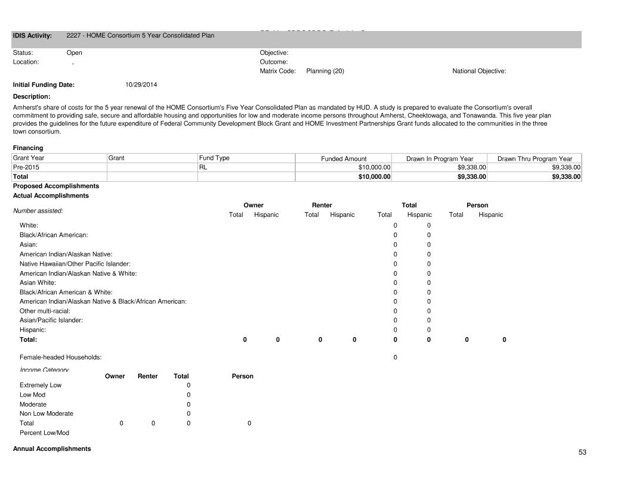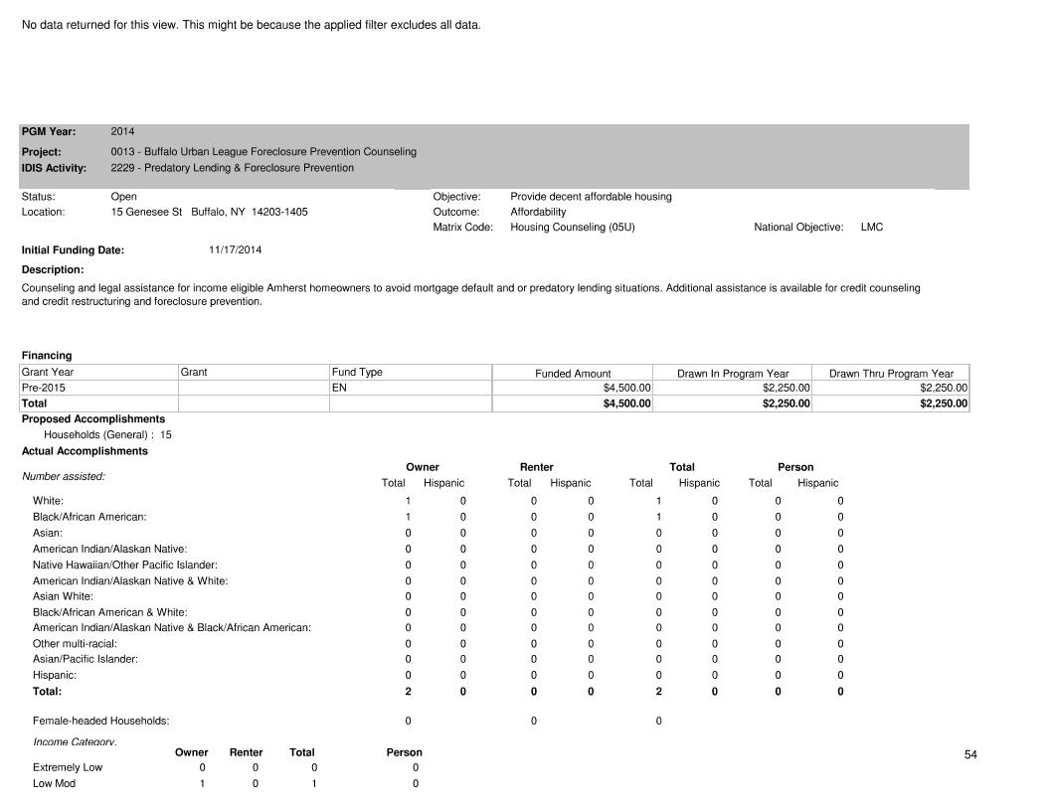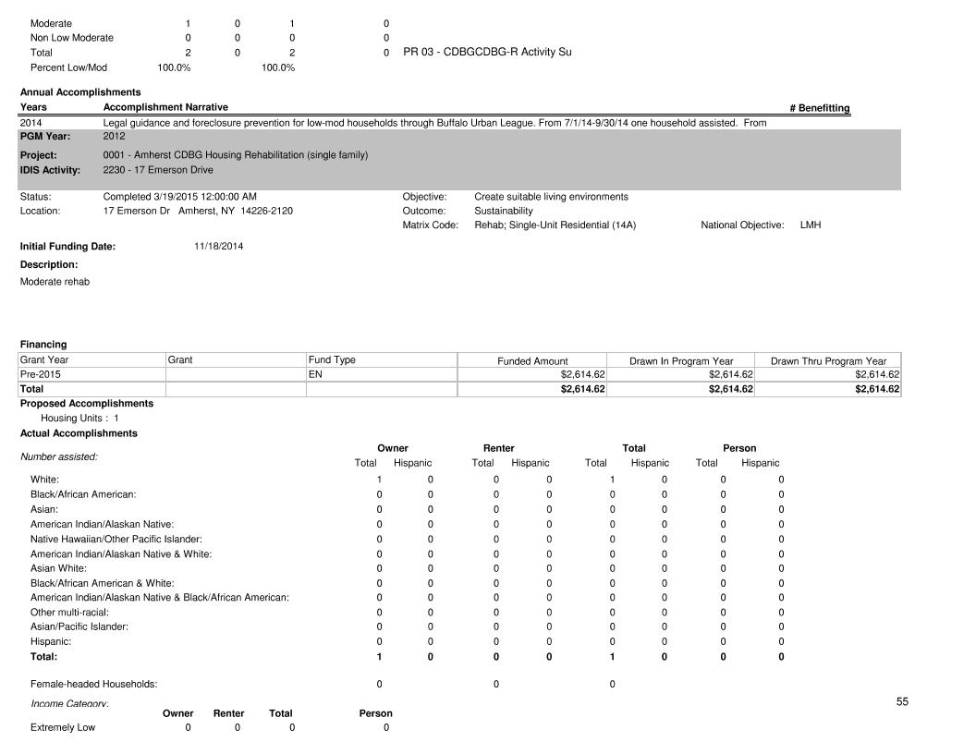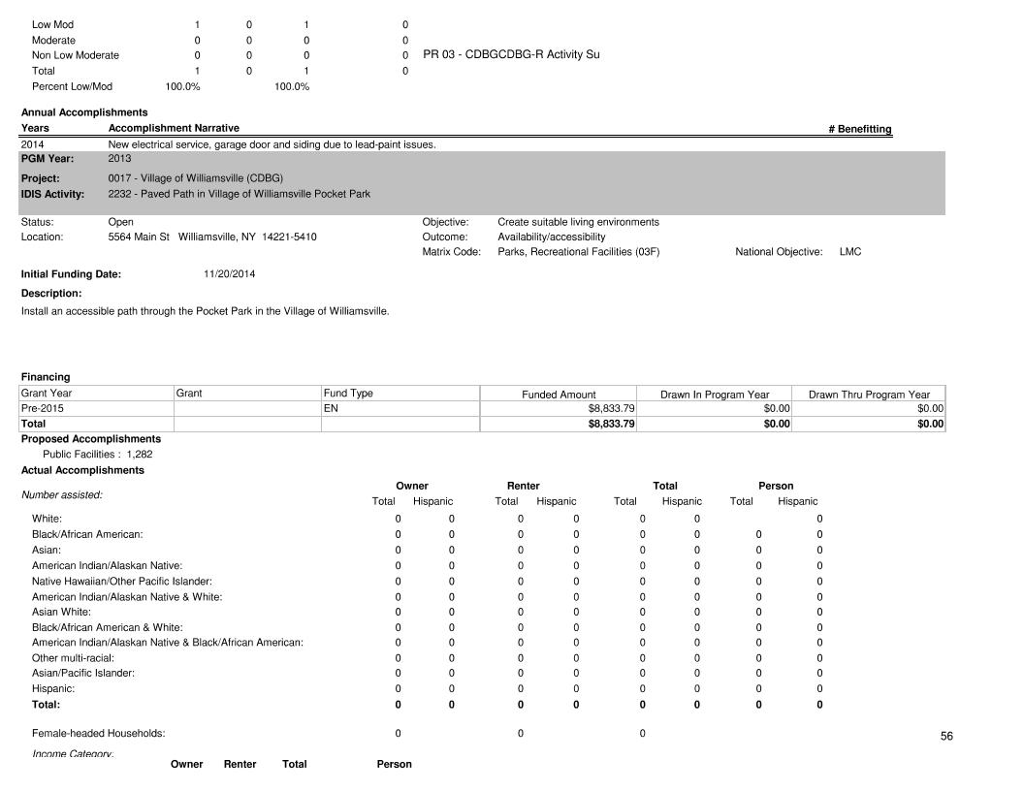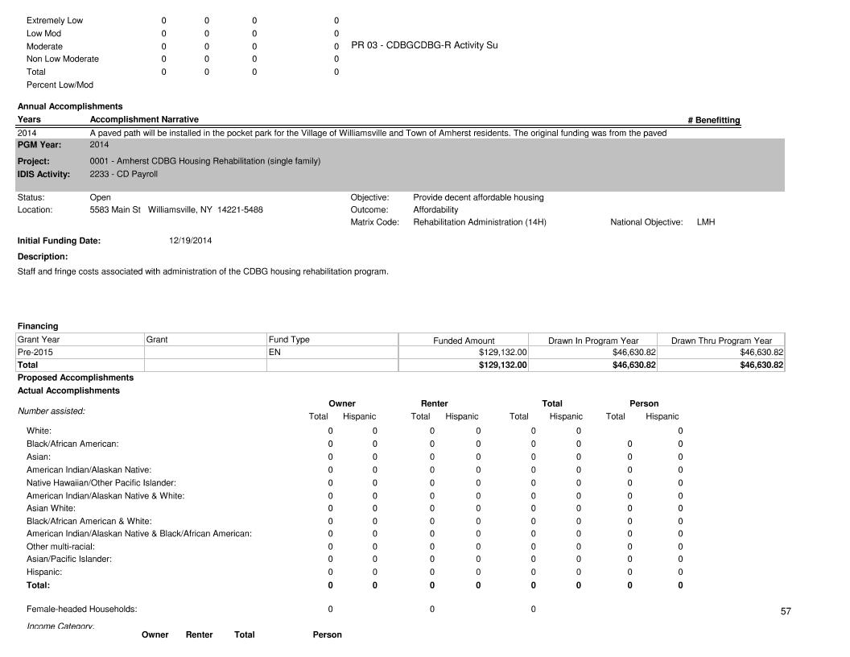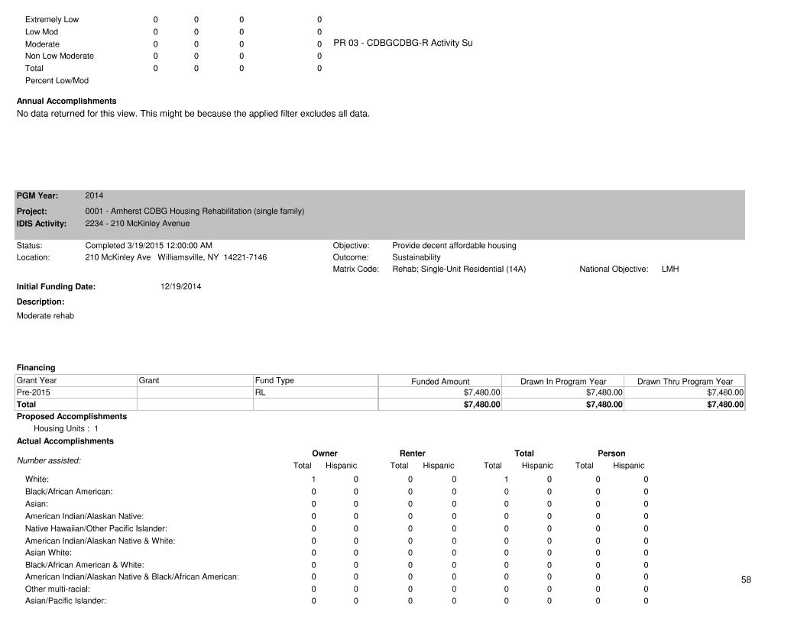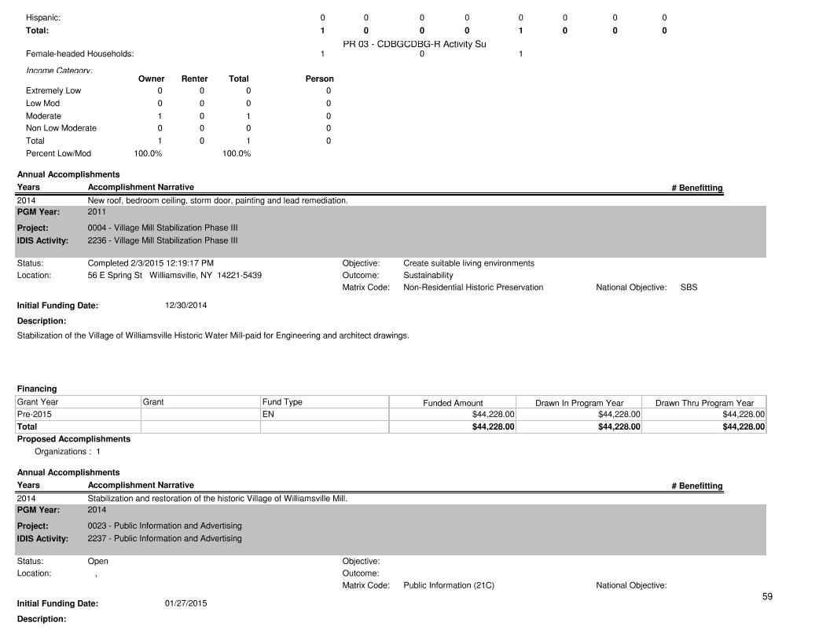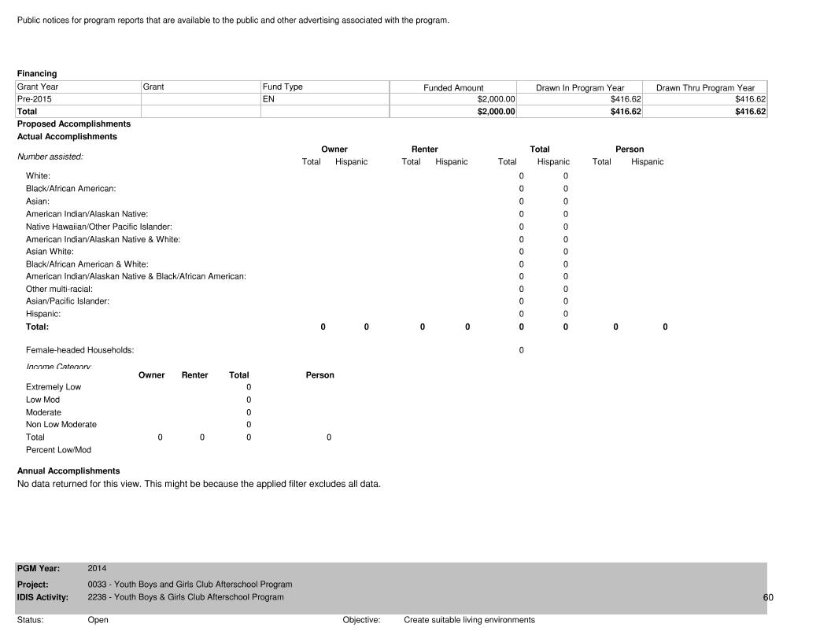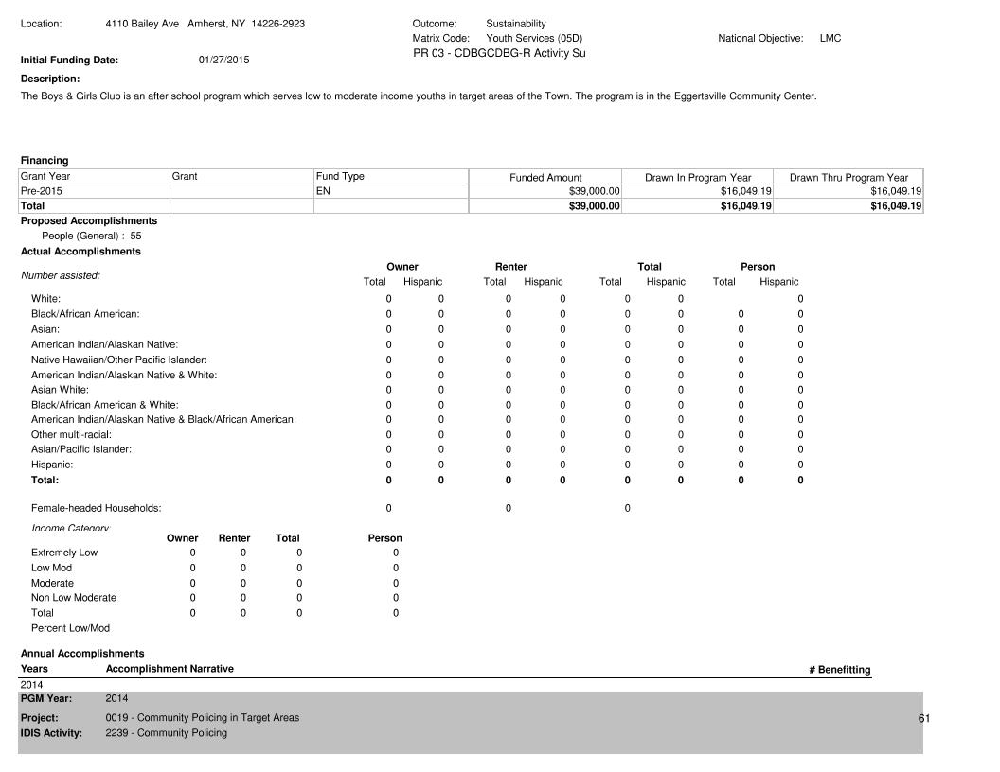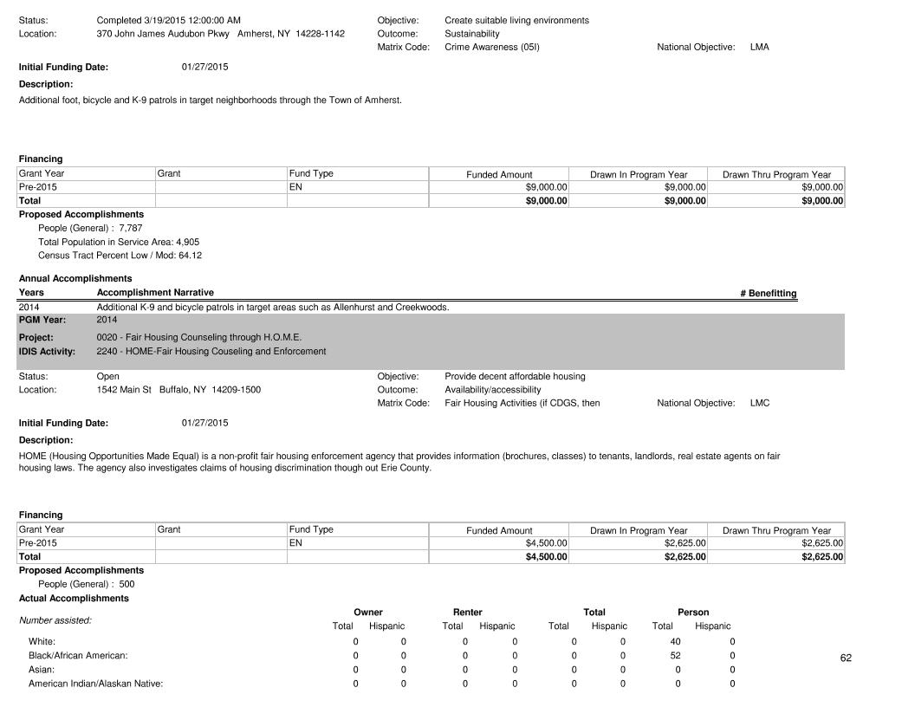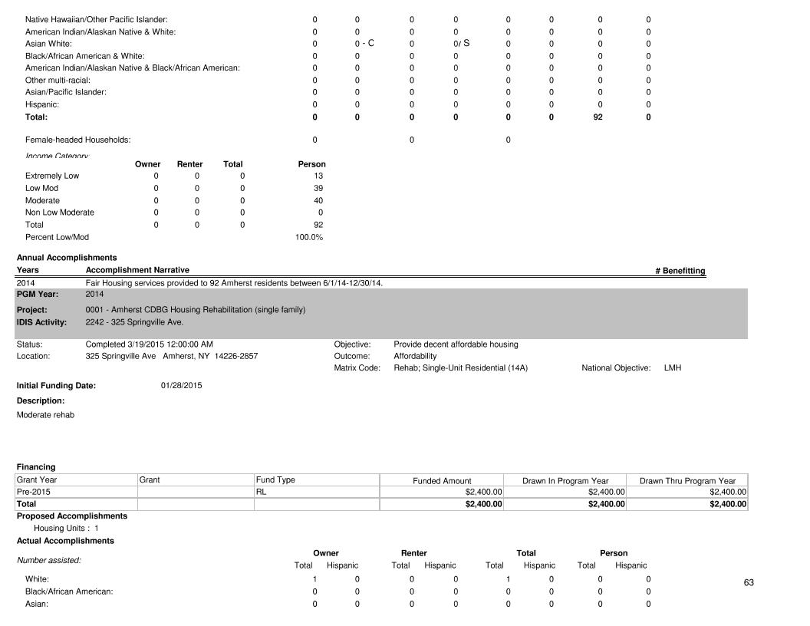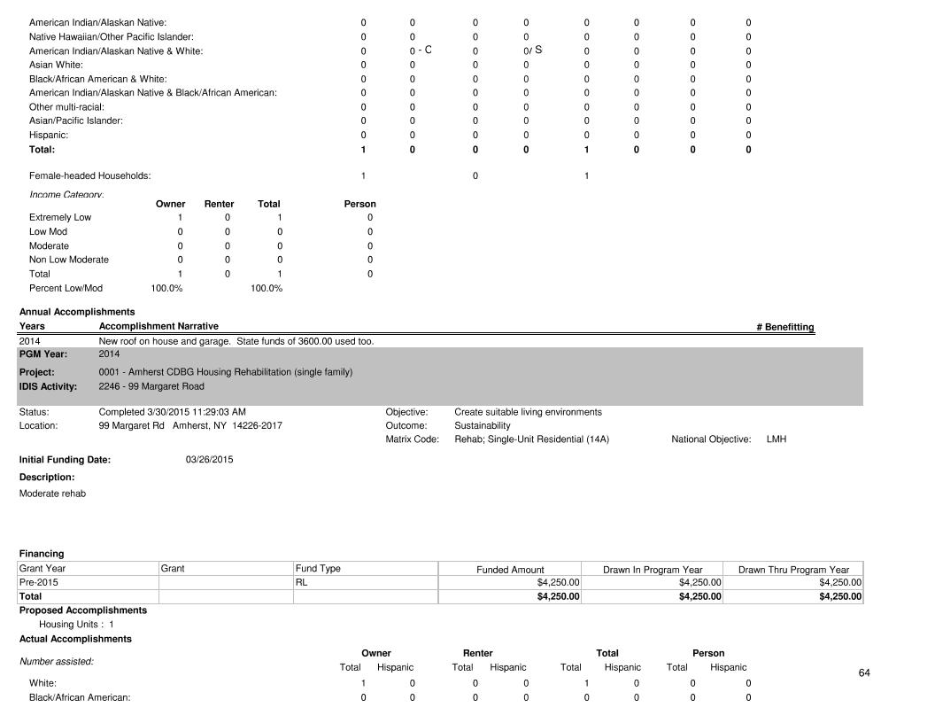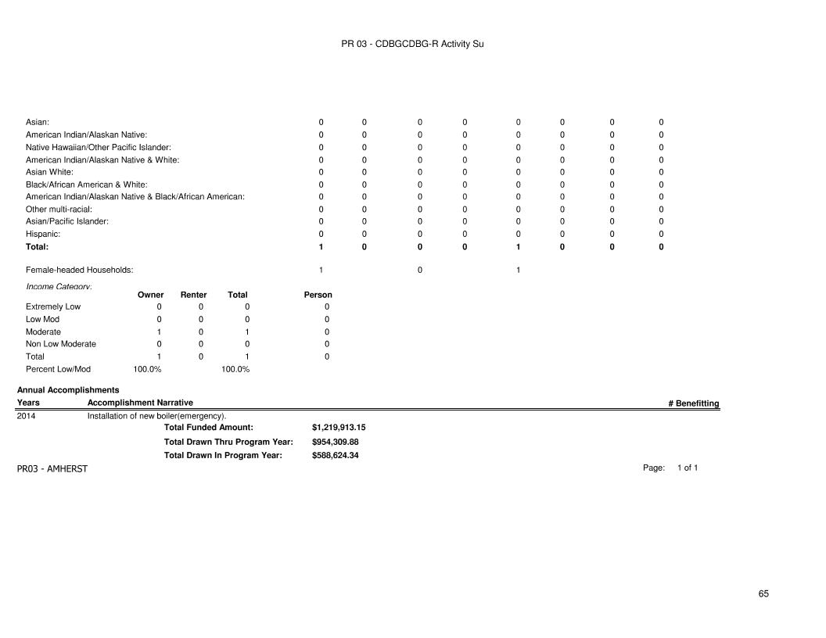

**PR83 Sec1 CDBG 2014 Performance Measures**

